

HPE Private Cloud AI TCO and ROI Analysis
vs On-Premises DIY, Cloud IaaS, Managed AI Platforms, and API Token Services
July 2026
HPE UKIMEA Private Cloud AI Team

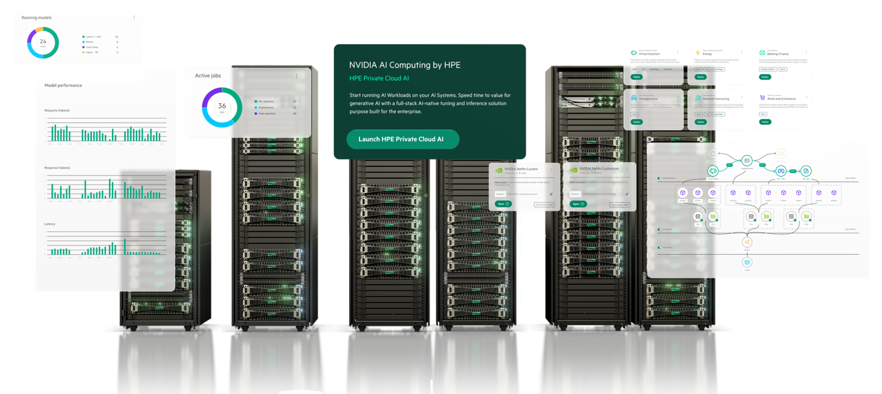
Disclaimer
This document has been generated with the assistance of AI tools. The information used to generate this document is all publicly available information and is fully cited / referenced throughout the document. HPE have reviewed, added and amended the content to ensure it is accurate and correct as of time of writing.
All assumptions and caveats are clearly stated throughout the document.

Table of Contents
HPE Private Cloud AI: Executive Positioning Preface 6
The Strategic and Economic Case Beyond the Base Comparison 6
The Tokenomics Problem: Why Traditional TCO Frameworks Are No Longer Sufficient 6
The Comparison Scenarios: Scale Context and the Trajectory That Matters 6
What Token Volumes Actually Look Like at Enterprise Maturity 6
The Service Desk Illustration: One Use Case, One Reframe 7
Beyond Token Economics: The Strategic Case for Private AI 8
Data Sovereignty and Regulatory Compliance 8
Intellectual Property Protection 8
Performance Predictability and Operational Certainty 8
Model Governance and Validated Change Management 8
The Jevons Paradox: Why Falling Token Prices Do Not Reduce Enterprise Spend 9
Governance as Competitive Advantage 9
Summary: The PCAI Value Case 9
HPE Private Cloud AI (Gen2 Medium) vs Cloud IaaS vs Managed AI Platforms vs API Token Services 10
Executive Summary 10
Key Finding: No Single Winner — Scenario Determines the Optimal Choice 11
Master 3-Year TCO Table 11
Critical Callouts 12
Recommendations 12
Section 1: Methodology & Assumptions 14
1.1 Scope and Approach 14
1.2 Key Assumptions 14
1.3 Token Volume Derivation 14
1.4 Platform Build Cost Methodology 15
1.5 Storage Methodology 15
Section 2: Platform A — HPE Private Cloud AI Gen2 Medium 16
2.1 Architecture Overview 16
2.2 H200 Throughput Baseline (MLPerf v5.0) 16
2.3 PCAI 109 TB Storage Allocation Breakdown 17
2.4 Day-1 Operational Stack (£0 Additional Engineering) 17
2.5 Platform A — Full 3-Year Cost Breakdown 18
Section 3: Platform B — Cloud IaaS GPU Instances 20
3.1 UK H200 Region Availability Status 20
3.2 Compute Pricing Summary 20
3.3 Platform Software Build & Integration Cost Model 20
Phase 1: Infrastructure Bring-Up (Weeks 1–16 elapsed) 20
Phase 2: AI Application Stack Build (Weeks 5–24 elapsed) 21
Phase 3: Ongoing Lifecycle Operations (Annual Recurring) 21
Committed Compute During Build Period 22
3.4 Full IaaS 3-Year TCO Comparison 22
Section 4: Platform C — Managed AI Platform Services 24
4.1 Per-Token Pricing (July 2026) 24
4.2 Integration Cost Model 24
4.3 Managed Platform 3-Year TCO 24
Section 5: Platform D — Direct API Token Services 25
5.1 API Pricing (July 2026) 25
5.2 Token Cost Workings (3-Year) 25
5.3 API Platform 3-Year TCO 25
Section 6: Cross-Platform Comparative Analysis 27
6.1 Storage Methodology Transparency 27
6.2 Deployment Timeline Comparison 27
6.3 Idle GPU Capital Cost Model 28
6.4 Time-to-Value Scoring 28
6.5 Qualitative Scorecard 28
Section 7: Scenario Analysis 29
Scenario 1: Cost-Optimised (Lowest 3-Year TCO) 29
Scenario 2: Compliance-Optimised (UK Data Sovereignty) 29
Scenario 3: Agility-Optimised (Fastest Time to Production Value) 29
Scenario 4: Engineering-Light (Minimum Human Capital Cost) 29
Section 8: Risk & Sensitivity Analysis 30
8.1 PCAI Sensitivity Analysis 30
8.2 Cloud IaaS Build Cost Overrun Scenario 30
8.3 API Price Escalation Scenario 30
8.4 Utilisation Sensitivity (PCAI Break-Even) 31
Section 9: Recommendations & Decision Framework 32
9.1 Decision Tree 32
9.2 The Cloud IaaS Trap 32
Section 10: Cloud Data Transfer Costs, Data Residency & Sovereignty 34
10.1 Data Transfer Costs: A Hidden Line Item in Cloud AI Deployments 34
10.2 The structural reality of enterprise data in 2026 34
10.3 What egress costs 34
10.4 Weighting the impact across the options analysed in this report 34
10.5 Data residency, sovereignty, and intellectual property 35
Section 11: Appendices 36
Appendix A: Primary Source Data 36
Appendix B: Token Volume Calculation Workbook 37
Appendix C: Staffing Model 37
Appendix D: UK Colocation Benchmark Data 37
Appendix E: MLPerf Benchmark 38
Appendix F: FX and Discount Rate Assumptions 38
Appendix G: Storage Allocation Detail 38
PCAI Internal Storage (~4 TB consumed, ~105 TB free headroom): 38
Appendix H: Platform Build Cost Work Breakdown Structure 38
Appendix I: Time-to-Value Model 40
PCAI Idle Capital Cost (4-week ramp-up): 40
AWS IaaS Committed Idle Cost (16-week build): 40
Value realisation gap (months 1–5): 40
Appendix J: Glossary 41
References 42
On-Premises DIY vs HPE Private Cloud AI: TCO & ROI Analysis 45
Executive Summary 45
Section 1: The 2026 GPU Supply Crisis — Structural constraint, not a Market Blip 46
1.1 Root Causes 46
Bottleneck 1: CoWoS Packaging Capacity 46
Bottleneck 2: HBM3e Memory Supply 46
Bottleneck 3: Hyperscaler Pre-emption 46
Bottleneck 4: H200 Scheduled End of Life 46
1.2 Current Lead Time Reality 46
1.3 Why HPE Has Priority Allocation 47
Section 2: Time-to-Production Comparison — The Full Picture 48
2.1 Realistic Timeline Modelling 48
DIY Timeline (2026 Reality) 48
HPE PCAI Timeline 49
2.2 The Timeline Gap: Visualised 49
Section 3: The True Economic Cost of the DIY Timeline Gap 51
3.1 Capital Committed on Day Zero 51
3.2 Idle Capital Cost Breakdown 51
3.3 Foregone Business Value 52
Section 4: Revised Three-Year TCO — Full Economic Model 53
4.1 Cost Stack (Unchanged from Prior Analysis) 53
4.2 Full Economic TCO Including Idle Capital and Foregone Value 53
4.3 Effective Cost Per Million Tokens (Full Economic Basis) 54
Section 5: Supply Chain Risk Modelling 55
5.1 Scenario Analysis: Hardware Lead Time Outcomes 55
5.2 Price Risk During DIY Lead Time 55
5.3 The Procurement Risk Comparison 56
Section 6: Platform Build Cost 57
Section 7: Hardware and Architecture Comparison 58
7.1 Technical Equivalence 58
7.2 Software Stack 58
Section 8: Pros, Cons, and Decision Framework 59
On-Premises DIY 59
8.1 DIY Advantages 59
8.2 DIY Disadvantages 59
HPE Private Cloud AI 60
8.3 PCAI Advantages 60
8.4 PCAI Disadvantages 60
Section 9: When DIY Remains Viable 61
Section 10: AI-Ready Networking — The Hidden Infrastructure Prerequisite 62
10.1 Assumption and Caveat 62
10.2 Why AI Workloads Demand a Fundamentally Different Network 62
10.3 The all-to-all traffic problem 62
10.4 Why RDMA, RoCEv2, and lossless networking are non-optional at multi-node scale 62
10.5 NVIDIA Spectrum-X: Why It Is Included in PCAI 63
10.6 What a DIY AI-Ready Fabric Actually Costs 63
10.7 Representative Hardware Bill of Materials 63
10.8 Design, Implementation and Validation 63
10.9 Operational Ongoing Costs 64
Section 11: The HPE Benchmark — Context and Caveats 65
Conclusion: On-Premises DIY vs HPE PCAI 66
Appendix: Key Assumptions and Data Sources 67
References 68

HPE Private Cloud AI: Executive Positioning Preface

The Strategic and Economic Case Beyond the Base Comparison

The Tokenomics Problem: Why Traditional TCO Frameworks Are No Longer Sufficient
Generative AI has become the fastest-growing line item in enterprise technology budgets, already consuming up to half of IT spend in some organisations (Deloitte, 2026). Cloud bills are rising nearly 20% year-over-year, driven overwhelmingly by AI workloads. Yet despite this investment surge, only 28% of global finance leaders say their AI investments are delivering clear, measurable value (Deloitte Global Finance Trends 2026).
The issue is not that AI fails to deliver value. It is that the cost frameworks used to evaluate AI investments were designed for a different era. Per-user licensing, static virtual machine pricing, and traditional TCO models assume predictable workloads and stable consumption. AI works differently. Every interaction consumes tokens. Every token carries a cost. And crucially, token demand scales in nonlinear and unpredictable ways, not just with the number of users, but with the complexity of each task, the depth of reasoning each model applies, and the architectural choices made throughout the AI stack (Deloitte, "The Pivot to Tokenomics", 2026).
Deloitte's 2026 analysis puts this plainly: "AI spend will likely separate value creators from value ‘eroders’. The former convert tokens into measurable enterprise output; the latter accumulate ungoverned cost that compounds quietly across the stack."
Understanding this distinction is the starting point for evaluating HPE Private Cloud AI not merely as a hardware investment, but as a strategic decision about how AI costs are structured, governed, and controlled across the lifetime of the platform.

The Comparison Scenarios: Scale Context and the Trajectory That Matters
The cost comparisons in this analysis are anchored at a 500-user deployment running a single-model inference workload. This is a deliberate and defensible starting point, it represents a common first production deployment, and the honest finding at this scale is that cloud API services are cheaper on a pure cash-outflow basis.
However, this starting point requires important context.
PCAI is not a pilot investment. The capital commitment, the supply chain lead time, the engineering deployment, and the operational model are all calibrated to production-scale AI at enterprise maturity. Evaluating PCAI against Year 1 token volumes is equivalent to evaluating a data centre against the compute needs of a single application. The infrastructure is designed for what the organisation will be running in Years 2 and 3; not what it is running on day one.

What Token Volumes Actually Look Like at Enterprise Maturity
Deloitte's 2026 TCO simulation models AI infrastructure costs across a realistic four-year adoption curve, progressing from simple chatbot/FAQ workloads in Year 1 through document summarisation and knowledge search in Year 2, to full decision-support and agentic co-pilot workflows by Year 3 and beyond. The token volumes that accompany this progression are not incremental, they are step-changes:

Maturity Stage | Example Workload | Annual Token Volume | Annual AI Factory TCO | Annual API TCO
Year 1 — Pilot | Simple chatbot, FAQ assistant | ~10 billion | $0.24M | $0.04M
Year 2 — POC/Adoption | Document RAG, knowledge search | ~300 billion | $0.49M | $1.06M
Year 3 — Production scale | Analytics co-pilot, agentic reasoning | ~1 trillion | $1.45M | $3.50M
Source: Deloitte "The Pivot to Tokenomics" TCO simulation, 2026 (Llama 3.3 70B FP8, NVIDIA HGX B200)

Over a three-year period, the AI factory (on-premises AI Factory such as PCAI) delivers more than 50% cost savings compared to both API-based and neocloud provider solutions at production-scale token volumes (Deloitte, 2026). The TCO per billion tokens falls by over 90% for the AI factory model as usage scales: from $24,000 per billion tokens at Year 1 to $1,450 at Year 3. For cloud API access, the equivalent reduction is only 64%, and the absolute cost remains vastly higher.
Deloitte identifies a specific inflection point: at approximately 84 billion tokens per year, the AI factory consistently reflects the lowest TCO of any deployment model — and from that point onwards, cloud API costs scale linearly with no ceiling, while AI factory costs remain broadly flat against a fixed infrastructure base.

The Service Desk Illustration: One Use Case, One Reframe
To make these token volumes tangible, consider a representative enterprise deployment: a business with 15,000 global employees enables AI for 450 service desk agents — just 3% of the workforce — for a single use case. Each complex escalation task involves RAG retrieval of 10+ internal policy documents, SLA compliance reasoning, and generation of a resolution plan:
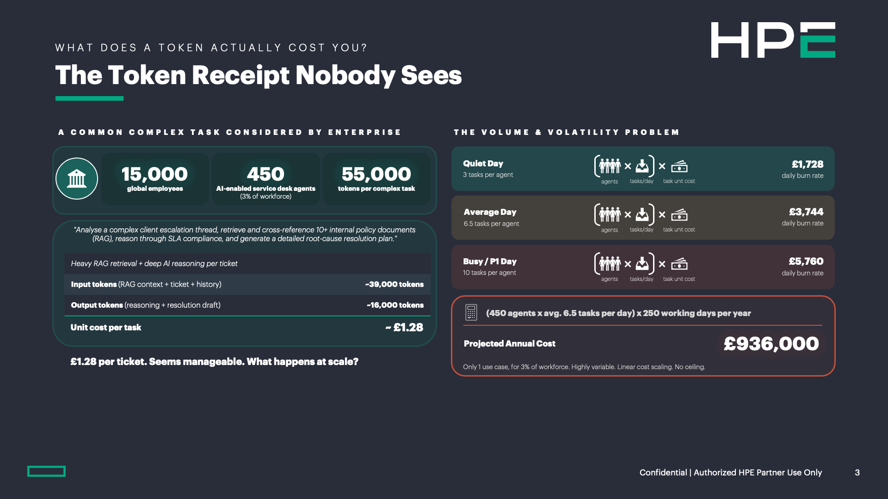
- Input tokens (RAG context + ticket history + policy documents): ~39,000
- Output tokens (reasoning + resolution draft): ~16,000
- Total: ~55,000 tokens per task
- Unit cost at cloud API rates: approximately £1.28 per ticket
At first glance, £1.28 per ticket appears entirely manageable. What it becomes at scale is the critical insight:

Daily Activity | Daily AI Cost
Quiet day — 3 tasks per agent | £1,728
Average day — 6.5 tasks per agent | £3,744
Busy / P1 incident day — 10 tasks per agent | £5,760
Projected annual cost — one use case, 3% of workforce | £936,000

This is not a budget. It is an open tab. And it carries one defining characteristic: linear cost scaling with no ceiling.
Every additional user, every additional use case, and every evolution from simple query to agentic workflow increases the bill in direct proportion. There is no breakpoint at which the marginal cost of the next token decreases.
HPE Private Cloud AI fundamentally changes this dynamic. Once deployed, the marginal cost of processing an additional token is the electricity to run the GPU; a known, bounded, and budgetable figure. Whether the platform processes 100 million tokens in a month or 10 billion, the infrastructure cost does not change.
PCAI is the only option in this comparison with a fixed cost ceiling. For any CFO or board-level sponsor evaluating AI economics over a multi-year horizon, this is a financial risk management characteristic as much as it is an infrastructure specification

Beyond Token Economics: The Strategic Case for Private AI
The financial comparison, even on a full economic basis, captures only part of the value proposition. For a significant number of enterprise procurement decisions, particularly in regulated industries, the non-financial dimensions of the choice are equally decisive, and in some cases are the primary selection criterion. These are not soft benefits appended to justify a cost premium; they are structural capabilities that cloud-hosted alternatives cannot replicate by design.

Data Sovereignty and Regulatory Compliance
HPE Private Cloud AI processes every prompt, document, model output, embedding, and fine-tuning dataset on infrastructure the customer owns, within a perimeter the customer controls. No data crosses a cloud boundary. No Transfer Risk Assessment is required under UK GDPR. No sub-processor list requires auditing. No third-party attestation substitutes for direct control.
For UK-domiciled organisations, this resolves a compliance exposure that no cloud provider contract can eliminate: the US CLOUD Act.
Any AI workload processed by a US-headquartered cloud provider, regardless of the physical location of the data centre, is potentially subject to US government access. For organisations processing commercially sensitive, legally privileged, clinically identifiable, or strategically proprietary data, this is not a theoretical concern. It is a documented legal mechanism that has been invoked in practice, and it is not addressed by standard data processing agreements.
PCAI supports fully air-gapped deployment for environments where even indirect external connectivity is not permissible: classified defence environments, critical national infrastructure, and highly regulated financial or clinical systems where any external network path is an unacceptable attack surface.

Intellectual Property Protection
Every document, model fine-tuning dataset, contract, source code file, or financial model processed through a cloud API traverses infrastructure the organisation does not own and cannot audit at the physical layer. Even where contractual IP protections are in place, the enforceability of those obligations against a major hyperscaler is structurally different from the protection afforded by hardware within the organisation's own operational control.
Open-source models running on PCAI, including LLaMA 3.3 70B and the broader NVIDIA NIM catalogue, introduce no "who trained on my data" ambiguity. Proprietary fine-tuned models, bespoke embeddings, and domain-specific adaptations remain wholly within the organisation's ownership and are never exposed to a shared multi-tenant environment.
Deloitte's analysis notes that self-hosted AI factory users are "the only buyer type with full trade-off control across cost, flexibility, and sovereignty"; a distinction that is structurally unavailable to cloud API consumers regardless of the contractual terms negotiated.

Performance Predictability and Operational Certainty
Cloud-hosted AI inference, whether through managed API or IaaS, shares GPU capacity with other tenants. Under periods of high platform demand, this produces non-deterministic latency, throughput degradation, and "noisy-neighbour" effects that manifest as inconsistent user experience and unreliable SLA delivery. These are not contractual failures on the provider's part; they are architectural consequences of shared infrastructure.
For latency-sensitive enterprise applications, for example real-time customer-facing AI, time-critical clinical decision support, financial advisory systems, or operational AI in manufacturing, non-deterministic performance is operationally unacceptable.
PCAI delivers dedicated compute, storage network and GPU capacity with a known throughput ceiling, a consistent latency profile, and no external dependency on provider infrastructure availability.
Deloitte identifies compute unit cost as one of the strongest differentiators of the on-premises model:
"Lowest latency — full control over hardware stack" — a characteristic that neocloud and hyperscaler options, by their shared architecture, fundamentally cannot match.

Model Governance and Validated Change Management
Cloud-hosted AI models are updated, replaced, and retired at the provider's discretion. Model swaps, sometimes silent, sometimes announced with limited notice, can alter the behaviour of validated workflows in ways that are difficult to detect and expensive to remediate. For regulated industries where AI model behaviour is subject to formal validation, audit, and approval cycles (MHRA, FCA, NHS Digital, ICO), an unannounced model update is a compliance event.
PCAI provides complete control over model versioning, update timing, and change management. The model version running in production is the version the organisation approved, tested, and documented. It remains so until the organisation actively decides to change it. This governance capability is not available through any cloud-hosted deployment model, regardless of tier or contract value.

The Jevons Paradox: Why Falling Token Prices Do Not Reduce Enterprise Spend
A common counterargument to infrastructure investment runs as follows: token prices are falling rapidly, so the cloud API cost case will improve over time, and the infrastructure investment becomes less justified. This argument misapplies the economics.
Deloitte's 2026 analysis explicitly addresses this dynamic, referencing Jevons' Paradox: "As efficiency improves, total consumption rises." Token prices are indeed falling, Deloitte projects average inference cost falling from $0.04 per million tokens in 2025 to approximately $0.01 by 2030. Yet enterprise AI spending continues to surge, because efficiency gains drive expanded adoption, more complex workloads, deeper agentic reasoning chains, and broader user penetration; consuming more total tokens even as each token costs less.
The implication is direct: falling per-token prices do not reduce the absolute AI spend of an enterprise that is scaling its AI usage. For any organisation whose AI programme is growing the cost trajectory of cloud API consumption is upward even as the unit price falls. The AI factory model absorbs this growth within a fixed infrastructure cost envelope.

Governance as Competitive Advantage
Deloitte's concluding framing for enterprise leaders is relevant here: "The competitive divide will not likely hinge on who adopts AI first, but on who manages its cost structure with discipline."
This is the governance dimension of the PCAI investment. The AI factory model, with its token-level cost visibility, fixed infrastructure cost base, model version control, and data sovereignty, creates the structural conditions for AI to scale predictably and responsibly. Organisations running cloud API AI at scale without these controls face what Deloitte describes as costs that "compound quietly across the stack"; visible on the invoice only after the damage is done.
PCAI is the infrastructure foundation that allows an organisation to convert token consumption into measurable enterprise value, rather than accumulating ungoverned cost that erodes both margin and strategic flexibility.

Summary: The PCAI Value Case

Dimension | Cloud API | HPE Private Cloud AI
Cost at pilot scale | Cheaper | More expensive
Cost at production scale (>84B tokens/yr) | Linear, uncapped growth | Fixed infrastructure ceiling
3-year TCO at 1 trillion tokens | ~$3.50M (Deloitte) | ~$1.45M (Deloitte) — 2.4× cheaper
Cost predictability | None — open tab | Fully bounded
Data sovereignty | Cloud boundary risk | Zero — all processing on-premises
US CLOUD Act exposure | Present for all US-HQ providers | Eliminated
IP protection | Contractual only | Structural — data never leaves perimeter
Model governance | Provider-controlled | Customer-controlled, audit-ready
Performance predictability | Noisy-neighbour risk | Dedicated GPU — consistent SLA
Agentic AI readiness | Costs multiply 5–30× per task | Fixed cost base absorbs growth

The base-comparison scenarios in this analysis correctly show that cloud API services are cheaper at conservative pilot-scale token volumes. This is the honest answer, and it is the right starting point for any credible assessment. The strategic framing, however, is different: PCAI is the infrastructure answer to the production-scale AI problem — the cost ceiling, sovereignty guarantee, governance control, and performance predictability that cloud-hosted alternatives cannot provide by design, at the token volumes that enterprise AI programmes will reach within the planning horizon of this investment.

Sources: Deloitte, "The Pivot to Tokenomics: Navigating AI's New Spend Dynamics", 2026. Goldman Sachs Research, AI Agents Token Consumption Forecast, May 2026. McKinsey State of AI 2025. HPE Private Cloud AI product documentation and partner guidance, 2025–2026.

HPE Private Cloud AI (Gen2 Medium) vs Cloud IaaS vs Managed AI Platforms vs API Token Services
Report Date: July 2026
Report Variables: Currency: GBP (£) | FX Rate: £1 = $1.2658 (i.e. $1 = £0.79, July 2026)

Executive Summary
This report presents a comprehensive, full-lifecycle Total Cost of Ownership (TCO) and Return on Investment (ROI) analysis comparing multiple categories of AI platform delivery models for a UK-based enterprise deploying an Enterprise RAG Knowledge Assistant for 500 users. All costs are modelled over a 3-year term aligned to the HPE PCAI commitment period, with NPV discounting at HMT Green Book 3.5% rate

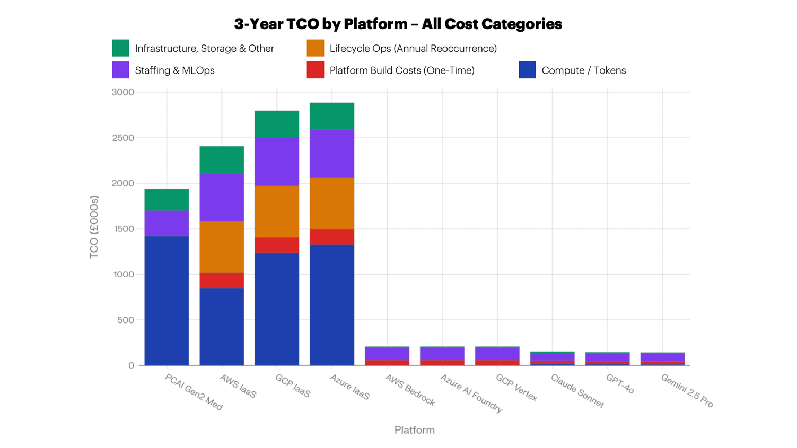
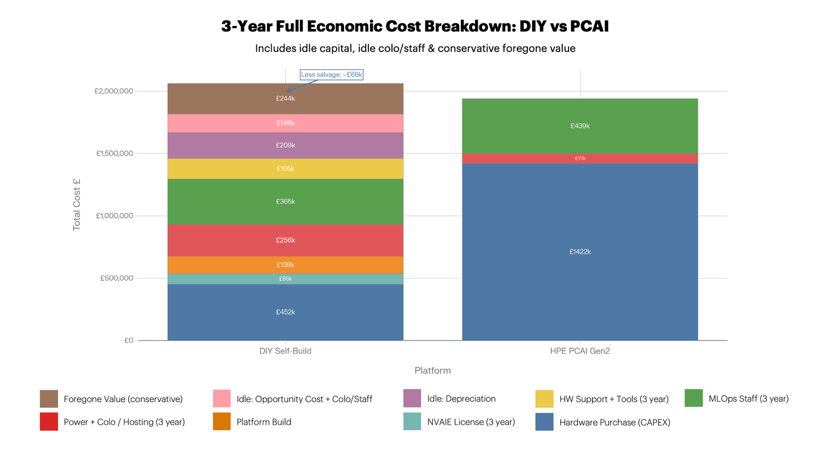

Key Finding: No Single Winner — Scenario Determines the Optimal Choice
Scenario | Winner | Rationale
Compliance-Optimised | PCAI Gen2 Medium | Highest UK data sovereignty, single vendor, no cloud transfer risk
Engineering-Light | API Token Services | Lowest engineering burden; fastest to value for <500 users
3-Year Cost (this use case) | API Token Services | Token volumes too low for on-prem economics to dominate
Scale (>10× token volume) | PCAI Gen2 Medium | Per-token cost advantage widens sharply at high utilisation
Hybrid Recommended | PCAI + API fallback | Sovereign processing on-prem; API for burst/overspill

Master 3-Year TCO Table
Platform | 3-Year TCO (£) | NPV @ 3.5%  (£) | £/1M  Tokens | TTF | TTP
PCAI Gen2 Medium | £1,938,435 | £1,904,288 | £492 | 4-6 wks | 12–16 wks
AWS IaaS (p5en/H200) | £2,406,254 | £2,334,066 | £611 | 8–20 wks | 20–52 wks
GCP IaaS (A3/H100) | £2,795,299 | £2,711,440 | £710 | 8–20 wks | 20–52 wks
Azure IaaS (ND H100v5) | £2,883,326 | £2,796,827 | £732 | 8–20 wks | 20–52 wks
AWS Bedrock (Llama 3.3 70B) | £206,786 | £250,113 | £52 | 2–4 wks | 8–16 wks
Azure AI Foundry | £206,755 | £250,084 | £52 | 2–4 wks | 8–16 wks
GCP Vertex AI | £206,786 | £250,113 | £52 | 2–4 wks | 8–16 wks
Claude Sonnet 4.6 API | £151,208 | £176,210 | £38 | <1 wk | 4–8 wks
GPT-4o API | £146,258 | £171,587 | £37 | <1 wk | 4–8 wks
Gemini 2.5 Pro API | £143,311 | £168,835 | £36 | <1 wk | 4–8 wks
*TTF = Time to First Inference | TTP = Time to Production*

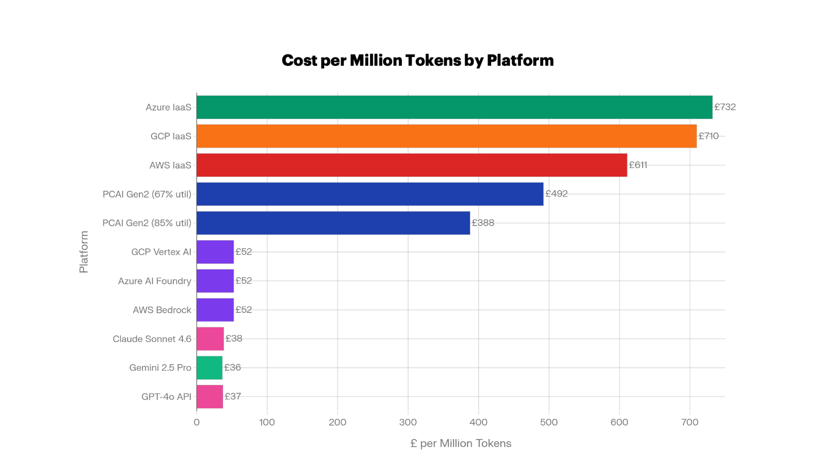

Critical Callouts
Platform Build Cost (Cloud IaaS): For all three cloud IaaS platforms, the cost of building and maintaining a production-equivalent software stack adds £732,550 to the 3-year TCO — representing 25–30% of total IaaS spend. This is systematically omitted from most cloud cost comparisons.[^{1][}2]
Time-to-Value Gap: PCAI delivers production-ready inference in approximately 4-6 weeks from PO versus 20–52 weeks for self-built cloud IaaS. This represents £86,939 in committed cloud compute billed before a single inference query is served, plus months of foregone business value.[^{3][}4] [^5]
Storage Methodology: Cloud storage for all comparison platforms is sized to the actual RAG workload (£0.4–3.5 TB over 3 years) — NOT the full 109 TB PCAI installed capacity (NOTE: the newly announced HPE PCAI with HPE Alletra X10000 storage starts at 62 TB of storage capacity). Using 109 TB as the cloud comparison figure would overstate cloud storage costs by 30–70×. Full methodology in Section 2 and Appendix G.
PCAI vs IaaS Cost Position: PCAI is 19–32% less expensive than equivalent cloud IaaS over 3 years when platform build, lifecycle operations, and idle capital costs are included. Without these hidden costs, IaaS appears cheaper — this is a structural gap in how cloud costs are typically evaluated.[^{6][}7]
API Dominance at This Scale: For the defined 500-user, 109M tokens/month use case, API token services are 9–13× cheaper than PCAI over 3 years. The economic crossover point to PCAI only occurs at approximately 10× this token volume, or when UK data sovereignty, model control, or vendor dependency risks make API services untenable.
Networking Assumption: It is assumed that in these cost comparisons the customer has an existing 100+ GbE, RDMA-capable, network fabric they can use for their on-premises builds / deployments. HPE PCAI is delivered with a fully architected, integrated, pre-configured and pre-tested NVIDIA Spectrum-X networking fabric. If this is not the case, significant additional costs will be incurred for the design, procurement, deployment, integration and subsequent lifecycle management of that new network fabric.

Recommendations
- Never compare PCAI to raw IaaS compute: Cloud IaaS requires £169k–£570k in additional engineering to reach PCAI-equivalent capability. Always include platform build cost in IaaS comparisons.
- Leverage PCAI's HMRC Full Expensing: PCAI hardware qualifies for 100% first-year capital allowance under UK Full Expensing, reducing the effective net cost by up to 25% in Year 1. [^8]
- Model for UK data sovereignty proactively: All hyperscaler managed platforms require careful review under UK GDPR / DPA 2018 and Schrems II transfer assessment before production deployment.[^{9][}10]
- Negotiate 3-year Savings Plans before committing to IaaS (regardless of cloud provider): If IaaS is chosen, for example AWS p5en 3year savings plans deliver ~32% discount over on-demand, reducing compute costs significantly — but platform build costs still apply. [^11]

Section 1: Methodology & Assumptions

1.1 Scope and Approach
This analysis models the complete, full-lifecycle TCO for deploying an Enterprise RAG Knowledge Assistant for 500 named users (100 peak concurrent) over a 3-year term. All four platform categories — on-premises private cloud, cloud IaaS, cloud managed AI platforms, and direct API services — are modelled with equal rigour and all mandatory cost categories from the prompt specification.

1.2 Key Assumptions

Parameter | Value | Source / Justification
FX Rate | £0.79 per USD ($1.2658/£) | July 2026 indicative rate; ±10% sensitivity applied
HMT Green Book Discount Rate | 3.5% | HM Treasury Green Book standard for public sector appraisal
UK Senior AI/ML Engineer Salary | £111,975 base | Indeed UK, June 2026[^12]
UK Senior Cloud/DevOps Engineer | £75,000–£95,000 | IT Jobs Watch, Firebrand Training July 2026[^{13][}14]
Engineer Day Rate (fully loaded) | £1,000/day | Mid of £800–£1,200 range; includes on-costs
Employer On costs (NI, pension) | +30% | Standard UK employer burden rate
UK Commercial Electricity | 25–26p/kWh | GLCG Q4 2025 averages [^15]
London CoLo Rack Rate | £155/kW/month | CBRE Global Data Centre Trends 2025 ($180–$215/kW) [^16]
H200 NVL GPU List Price | $35,000/GPU | Mid of $30,000–$40,000 range [^17]
PCAI System Price | $1,800,000 / 3yr | HPE supplied value
HMRC Full Expensing | 100% first-year allowance | PwC UK — permanent from April 2023[^8]

1.3 Token Volume Derivation

Complete workings:

Metric | Calculation | Value
Sessions per business day | 250 DAU × 5 sessions | 1,250 sessions/day
Tokens per session | 2,500 input + 800 output | 3,300 tokens
Business-hours tokens/day | 1,250 × 3,300 | 4,125,000 tokens/day
Daily total (incl. 10% off-peak) | 4,125,000 × 1.10 | 4,537,500 tokens/day
Monthly token volume | Annual ÷ 12 | ~109.4M tokens/month
Annual token volume | Full model | ~1,313M tokens/year
3-year token volume | × 3 | ~3,939M tokens

This normalised token volume is used for all API-based cost calculations.

1.4 Platform Build Cost Methodology
Cloud IaaS platform build costs are derived from published industry sources:
- gpucloudcost.com: "Realistic first-year implementation budget for a mid-market H100 cluster runs 15–30% of the raw GPU-compute line"[^1] ciq.com: "AI infrastructure teams consistently report spending 30–50% of their engineering time on infrastructure work: configuring CUDA environments, debugging driver conflicts, rebuilding nodes a er dependency failures"[^2]
- Phase 1 (infrastructure bring-up): 33–70 engineer-days; Phase 2 (AI application stack): 73–162 engineer-days; Phase 3 (lifecycle): 1.2–2.2 FTE annually

1.5 Storage Methodology
Cloud storage is sized to the RAG workload only (Section 2 below), NOT the PCAI's full 109 TB installed capacity. The 109 TB figure represents total platform capacity including ~105 TB of free headroom. Comparing cloud storage against 109 TB would produce a 30–70× overstatement of cloud storage costs.

Section 2: Platform A — HPE Private Cloud AI Gen2 Medium

2.1 Architecture Overview

Component | Specification
Worker Nodes | 2 × AI Worker Nodes
GPUs | 8 × NVIDIA H200 NVL (141 GB HBM3e, PCIe, air-cooled)
Total GPU  Memory | 1,128 GB HBM3e
GPU Interconnect | NVLink bridge (2-way in MEDIUM)
AI Network Fabric | RDMA Capable 400 GbE NVIDIA Spectrum-X
Storage | 109 TB RDMA Capable — HPE GreenLake for File Storage
Software Stack | NVIDIA AI Enterprise, HPE AI Essentials, NVIDIA NIM microservices, HPE VME, HPE Morpheus, HPE Ezmeral Container Runtime, HPE MLIS plus many fully integrated and lifecycled, industry recognised Open-Source AI tools and frameworks
Management | HPE GreenLake cloud console, HPE OpsRamp (+ OpsRamp AI Copilot)
Support | HPE Services (full-stack hardware + software - single vendor support model)

2.2 H200 Throughput Baseline (MLPerf v5.0)
MLPerf Inference v5.0 (April 2025) introduced the Llama 2 70B benchmark as the highest submission rate test. The highest performing system with H200 NVL GPUs achieved 2,247 tokens/second per GPU in the server scenario, yielding approximately 18,000 tokens/second gross for 8 GPUs (although this value is largely representative of most 8-way systems on test).[^{18][}19]

Metric | Value | Source
Gross TPS (8×H200, server scenario, Llama 2 70B) | ~18,000 tokens/sec | MLPerf v5.0[^18]
Enterprise utilisation factor | 67% average / 85% peak | Multi-tenancy, prefill/decode ratio overhead
Effective sustained TPS (67%) | ~12,060 tokens/sec | Derived
Effective peak TPS (85%) | ~15,300 tokens/sec | Derived
LLaMA 3.3 70B on H200 (FP8) | ~13,000+ TPS | Lambda H200 13% improvement over prior best [^20]
Max supported concurrent sessions (at TTFT <3s) | ~35–45 sessions | At 100 concurrent users, headroom is adequate

- Model selection: LLaMA 3.3 70B (primary) deployed via NVIDIA NIM microservices on PCAI. NIM supports BF16, FP8, and NVFP4 profiles for Llama 3.3 70B, with FP8 reducing disk footprint from ~140 GB to ~70 GB.[^{21][}22]
- LLaMA 3.1 405B feasibility: The 8×H200 NVL configuration (1,128 GB HBM3e total) can host LLaMA 3.1 405B at FP8 (≈202 GB model weights, requires TP8 across all 8 GPUs). However, throughput degrades significantly vs 70B — estimated 60–70% reduction to ~5,400–7,200 effective TPS at 67% utilisation. CoreWeave achieved ~800 TPS/GPU on 405B with GB200 (vs H200), confirming H200 405B throughput is substantially lower.[^{23][}24]

2.3 PCAI 109 TB Storage Allocation Breakdown

Storage Allocation Category | Estimated Allocation | Source
Model weights — LLaMA 3.3  70B BF16 on disk | ~138 GB GPU memory /  ~180 GB recommended | NVIDIA NIM official system card: "bf16: 138 GB min / 180 GB recommended"[^25]; Spheron: ~154 GB VRAM incl. KV cache at  FP16[^26]
Quantised cache (FP8 profiles) | ~69 GB GPU memory / ~90  GB recommended | NVIDIA NIM official: "fp8: 69 GB min / 90 GB recommended"  [^25]; FP8 reduces exactly 50% vs BF16
Secondary models & LoRA adapters | ~200–400 GB | NV-Embed-v2, reranker models, LoRA adapters
NVIDIA AI Enterprise container images | ~50–100 GB | NGC catalog containers, base OS layers
Kubernetes control plane | ~50–100 GB | etcd, persistent volumes, Helm artefacts
HPE AI Essentials & management plane | ~100–200 GB | OpsRamp, telemetry, audit logs, Ezmeral state
Observability & monitoring stack | ~50–100 GB | Prometheus TSDB, Grafana, Loki, Jaeger
Vector database index  (Milvus/pgvector) | ~500 GB – 2 TB | Self-hosted vector DB on PCAI storage
Document corpus raw storage | ~1–5 TB | Source documents for RAG knowledge base
Pipeline artefacts & CI/CD | ~100–200 GB | MLflow, pipeline DAGs, container build cache
OS, drivers, firmware, CUDA | ~50–100 GB | RHEL/Ubuntu, NVIDIA drivers, OFED stack
Free headroom (~20% best practice) | ~100–105 TB | Strategic reserve for expansion, model upgrades
TOTAL | 109 TB

Key finding: Of the 109 TB total, approximately 3–9 TB is consumed by platform-internal functions and the initial RAG workload. The remaining ~100–105 TB is available for corpus expansion, additional workloads, and model upgrades over the 3-year term — at zero additional storage cost.

2.4 Day-1 Operational Stack (£0 Additional Engineering)
PCAI delivers the following as pre-configured, pre-validated components — all at £0 additional engineering effort vs cloud IaaS:[^{27][}5]

Component | PCAI Status | Cloud IaaS Equivalent Cost
GPU drivers, CUDA, OFED | Pre-installed, HPE/NVIDIA validated | 5–10 engineer-days (£5,000–£10,000)
NVIDIA AI Enterprise suite | Licensed + pre-configured (5yr) | $36,000/yr BYOL + installation
NVIDIA NIM inference microservices | Pre-deployed, model-ready | 5–10 engineer-days + Helm config
Validated RAG/agent blueprints | Included | Must source, adapt, integrate from scratch
HPE AI Essentials orchestration | Pre-integrated | No cloud equivalent
HPE Ezmeral Runtime Enterprise (K8s) | Pre-deployed production-ready | EKS/GKE/AKS provisioning + GPU operator
HPE GreenLake management console | Pre-configured, single pane | Assembled from  CloudWatch/Stackdriver/Monitor
HPE OpsRamp AI observability | Included | Must procure or build
109 TB storage (AI-configured) | Pre-configured | Provision + tune separately
400 GbE Spectrum-X networking | Pre-configured, optimised | Hyperscaler-managed (no equivalent config)
Security baseline, RBAC, audit logging | Pre-configured enterprise standard | Design, implement, validate
90-day HPE PCAI Customer Engineering platform adoption acceleration service | Included | Would require packaged education services or consulting support from partner(s)
HPE Services support | Single-vendor HW+SW+FW | Multi-vendor coordination
Firmware/driver lifecycle | HPE-managed, automated | Customer-managed manual update cycles

HPE states: "Go from AI idea to production in weeks, not months, with turnkey private AI infrastructure built to speed time to value" and "in less than four weeks, you can have a pilot running".[^{28][}5]

2.5 Platform A — Full 3-Year Cost Breakdown

Cost Category | Annual (£) | 3-Year Total (£) | Notes
Hardware / System (CAPEX) | n/a | £1,422,000 | 1,800,000 x £0.79
Data centre colocation (22kW @ £155/kW/mo) | £40,920 | £122,760 | London/M25 tier; CBRE 2025 rates [^16]
Cross-connects / networking | £3,600 | £10,800 | Typical UK CoLo cross-connect
Staffing (0.75 FTE ML/Plat + Sec) | £92,625 | £277,875 | £111,975 AI Eng base × on costs [^12]
Training & skills | £8,000 | £24,000 | Vendor certifications, upskilling
Security & compliance tooling | £12,000 | £36,000 | Pen testing, GDPR tooling
DR / BCP (backup, runbooks) | £15,000 | £45,000 | Offsite backup, DR testing
Platform build & integration | £0 | £0 | Turnkey — included in system price
Additional storage | £0 | £0 | 109 TB included in $1.8M
NVIDIA AI Enterprise licence | £0 | £0 | 5-year subscription included with H200  NVL
Monitoring / observability | £0 | £0 | HPE OpsRamp + Prometheus included
Total Annual OPEX | £172,145
TOTAL 3-YEAR TCO |  | £1,938,435
NPV @ 3.5% (HMT Green Book) |  | £1,904,288
Cost per 1M tokens @ 67% utilisation |  | £492
Cost per 1M tokens @ 85% utilisation |  | £388
Cost per concurrent user/month |  | £538
Cost per named user/month |  | £108

HMRC Tax Position: The £1,422,000 hardware spend qualifies for 100% first-year capital allowance under UK Full Expensing (plant and machinery), providing a Year 1 corporation tax deduction worth up to £355,500 (25% effective rate) — reducing the effective net hardware cost to approximately £1,066,500. [^8]
Power costs: 8 × H200 NVL TDP 700W = 5,600W GPU load. Full rack estimated 20–22 kW including server infrastructure. UK commercial electricity ~26p/kWh; annual electricity ~£46k. This is typically included within the colocation tariff (PUE 1.4 assumed).[^{15][}29]
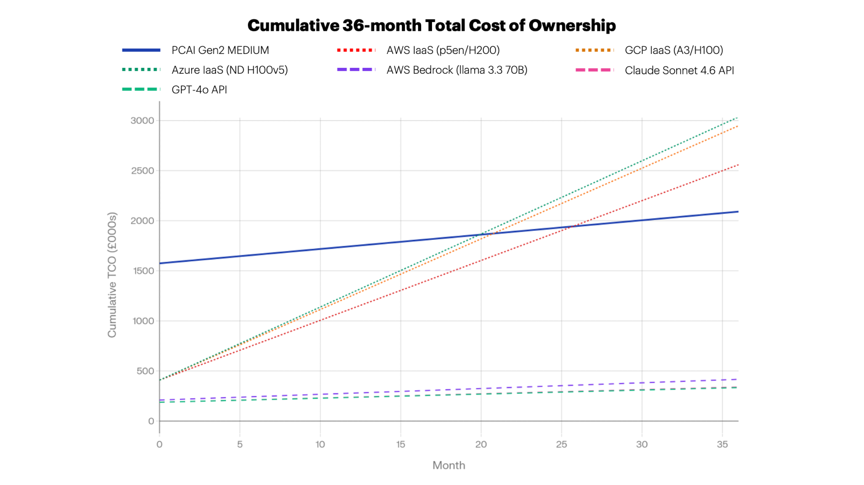

Section 3: Platform B — Cloud IaaS GPU Instances

3.1 UK H200 Region Availability Status

Provider | UK Region | H200 Availability | Notes
AWS | eu-west-2  (London) | Available — p5en.48xlarge  (8×H200) | $63.296/hr on demand; capacity blocks at $6.241/GPU/hr non-US [^30]
GCP | europe-west2  (London) | H100 only (A3 High) | H200 not confirmed in europe-west2; A3 Ultra (H200) not in  EU yet as of July 2026[^31]
Azure | UK South | H100 (ND H100 v5) | H200 not yet generally available in UK South [^32]

IMPORTANT: GCP and Azure require H100-class instances for UK region; performance gap vs H200 applies. AWS p5en provides true H200 in UK (eu-west-2).

3.2 Compute Pricing Summary

Provider | Instance | GPU | On-Demand (/hr) | 3yr Committed (/hr) | 3-Year Compute Cost (£)
AWS | p5en.48xlarge | 8×H200 | $63.30[^33] | ~$40.94 (est.) | £849,983
GCP | a3-highgpu-8g | 8×H100 | $87.84[^31] | ~$59.68 (3yr CUD) | £1,239,028
Azure | ND H100 v5 (8 GPU) | 8×H100 | ~$98.32[^32] | ~$63.92 (3yr reserved) | £1,327,056
Note: AWS p5en pricing increased ~15% June 2026; 3yr savings plan rates include ~32% discount [^{34][}11]

3.3 Platform Software Build & Integration Cost Model
This is the single most important differentiator between cloud IaaS and PCAI. A bare GPU instance is not a production AI platform. The engineering effort required to bridge the gap is substantial, routinely underestimated, and must be included in any honest TCO.[^{2][}7]

Phase 1: Infrastructure Bring-Up (Weeks 1–16 elapsed)

Work Stream | Elapsed Time | Engineer-Days | Source
GPU instance quota + provisioning | 2–8 weeks | 2–5 days | gpucloudcost.com: "hyperscaler quota: 4–8 weeks"[^1]
GPU driver, CUDA, OFED installation + validation | 3–10 days | 5–10 days | ciq.com: "takes experienced engineer hours before a single model runs"[^2]
NVIDIA GPU Operator / K8s device plugin | 3–5 days | 3–5 days
Managed K8s cluster  (EKS/GKE/AKS) + GPU nodepool | 1–2 weeks | 5–10 days
Distributed file system / shared storage setup | 1–4 weeks | 5–15 days | gpucloudcost.com: "1–4 weeks for productiongrade setup"[^1]
Container registry, secrets, IAM | 3–5 days | 3–5 days
NVIDIA NIM deployment (Helm, model cache, TRT) | 1–2 weeks | 5–10 days
Inference framework tuning  (vLLM/TRT-LLM) | 1–2 weeks | 5–10 days
Phase 1 Total | 6–16 weeks elapsed | 33–70 engineer-days

Phase 2: AI Application Stack Build (Weeks 5–24 elapsed)

Work Stream | Elapsed Time | Engineer-Days
RAG pipeline design and build | 3–6 weeks | 15–30 days
Vector database selection + deployment | 1–3 weeks | 5–10 days
Embedding model deployment + serving | 1–2 weeks | 3–7 days
API gateway, rate limiting, authentication | 1–2 weeks | 5–10 days
LLM observability and tracing | 1–2 weeks | 5–10 days
Security review + pen testing baseline | 2–4 weeks | 5–15 days
CI/CD pipeline | 1–3 weeks | 5–10 days
User interface + enterprise integrations | 3–8 weeks | 15–40 days
Testing, load testing, performance validation | 2–4 weeks | 10–20 days
Documentation and operator training | 1–2 weeks | 5–10 days
Work Stream | Elapsed Time | Engineer-Days
Phase 2 Total | 10–24 weeks elapsed | 73–162 engineer-days

One-time build cost (Phase 1 + 2): 169 engineer-days (mid) × £1,000/day = £169,000[^{1][}2]

Phase 3: Ongoing Lifecycle Operations (Annual Recurring)

Work Stream | Annual FTE
OS, kernel, driver, CUDA patching + validation | 0.25–0.5 FTE
Kubernetes version upgrades | 0.1–0.2 FTE
NIM microservices updates, model version management | 0.2–0.3 FTE
Security patching + compliance auditing | 0.2–0.3 FTE
Monitoring stack maintenance | 0.1–0.2 FTE
Incident response + break-fix (no single vendor) | 0.2–0.4 FTE
Capacity planning + FinOps | 0.1–0.2 FTE
Annual lifecycle total | ~1.2–2.2 FTE (mid: 1.7 FTE)

Annual lifecycle cost: 1.7 FTE × £85,000 base × 1.30 on costs = £187,850/year → £563,550 over 3 years
ciq.com notes: "40% of every AI engineer's time not spent building AI" is consumed by infrastructure maintenance. The AI engineer era has a structural infrastructure overhead problem. [^2]

Committed Compute During Build Period
AWS reserved instances commit from Day 1. Phase 1+2 build takes 16 weeks (conservative mid):
- 16 weeks × 168 hours × £32.34/hr (AWS 3yr rate) = £86,939 in committed spend before first inference query [^1]

3.4 Full IaaS 3-Year TCO Comparison

Cost Category | AWS (£) | GCP (£) | Azure (£)
Compute (3yr committed) | 849,983 | 1,239,028 | 1,327,056
NVAIE BYOL ($4,500/GPU/yr × 8) [^35] | 85,320 | 85,320 | 85,320
Storage (RAG workload) [^{36][}37] | 4,145 | 4,145 | 4,145
EKS/GKE/AKS + networking | 6,816 | 6,816 | 6,816
Security, training, monitoring | 114,000 | 114,000 | 114,000
Platform Build (Phase 1+2) | 169,000 | 169,000 | 169,000
Lifecycle Ops (Phase 3, 3yr) | 563,550 | 563,550 | 563,550
Committed idle during build | 86,939 | 86,939 | 86,939
Application/MLOps staffing (3yr) | 526,500 | 526,500 | 526,500
TOTAL 3-YEAR TCO | £2,406,254 | £2,795,299 | £2,883,326
Build cost as % of TCO | 30.4% | 26.2% | 25.4%
vs PCAI Gen2 | +£467,819 (+24%) | +£856,864 (+44%) | +£944,891 (+49%)
"Cloud IaaS is not a cheaper version of PCAI — it is raw compute that must be transformed into a production AI platform at significant engineering cost and time. The true comparison is: PCAI price vs (IaaS compute + platform build + lifecycle + staffing + delayed ROI)."
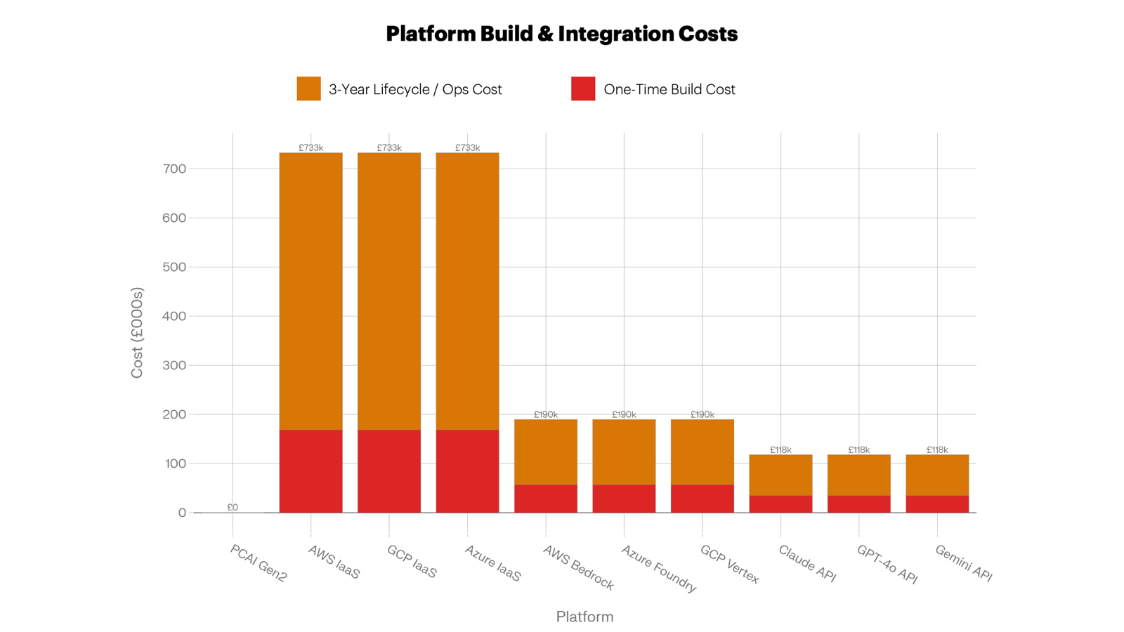

Section 4: Platform C — Managed AI Platform Services
Managed AI platforms (AWS Bedrock, Azure AI Foundry, GCP Vertex AI) abstract the GPU layer entirely. Phase 1 infrastructure build is near-zero; Phase 2 application development costs are like IaaS; ongoing lifecycle management is substantially reduced.

4.1 Per-Token Pricing (July 2026)

Provider | Model | Input ($/1M) | Output ($/1M) | Source
AWS Bedrock | Llama 3.3 70B Instruct | $0.72 | $0.72 | go-cloud.io, verified June 2026[^38]
Azure AI Foundry | Llama 3.3 70B Instruct | $0.71 | $0.71 | FutureAGI, verified June 2026[^39]
GCP Vertex AI | Llama 3.3 70B Instruct | $0.72 | $0.72 | TypingMind calculator [^40]

4.2 Integration Cost Model

Phase | Elapsed Time | Engineer-Days | Cost (£)
Phase 2 (app stack only — no infra) | 6–10 weeks | 45–70 days | £57,000 (mid)
Ongoing: 0.4 FTE (prompt eng, cost governance) | Annual recurring | 0.4 FTE | £44,200/yr

4.3 Managed Platform 3-Year TCO

Cost Category | AWS Bedrock | Azure AI Foundry | GCP Vertex AI
Token cost (3yr, ~3,939M tokens) | £2,240 | £2,209 | £2,240
Platform build (Phase 2) | £57,000 | £57,000 | £57,000
Ongoing operations (3yr, 0.4 FTE) | £132,600 | £132,600 | £132,600
Managed vector DB (£300/mo × 36) | £10,800 | £10,800 | £10,800
Storage (RAG workload) | £4,145 | £4,145 | £4,145
TOTAL 3-YEAR TCO | £206,786 | £206,755 | £206,786
NPV @ 3.5% | £250,113 | £250,084 | £250,113
£/1M tokens | £52 | £52 | £52
Important: At this token volume, managed platform token costs are negligible (£2,240/3yr). The dominant cost is engineering (build + ops). Managed platforms become significantly more expensive at higher volumes.

Section 5: Platform D — Direct API Token Services
Direct API services offer the lowest 3-year TCO for this use case, with the fastest time to first inference and the lowest engineering burden. The trade-off is data sovereignty, model control, and per-token cost escalation at high volumes.

5.1 API Pricing (July 2026)

Provider | Model | Input ($/1M) | Output  ($/1M) | Source
Anthropic | Claude Sonnet 4.6 | $3.00 | $15.00 | platform.claude.com[^41] (introductory $2/$10 through Aug  2026[^41])
OpenAI | GPT-4o² | $2.50 | $10.00 | openai.com/api/pricing[^42]
Google | Gemini 2.5 Pro² | $1.25 | $10.00 | Finout.io Gemini 2026 pricing [^43]
Model equivalence to LLaMA 3.3 70B: Sonnet 4.6, GPT-4o, and Gemini 2.5 Pro are capability-equivalent to LLaMA 3.3 70B class for enterprise RAG applications. The per-token rate differential reflects closed-model premium.

5.2 Token Cost Workings (3-Year)
Total 3-year tokens: ~3,939M (2,984M input + 955M output)

Provider | Input Cost ($) | Output Cost ($) | Total USD | Total GBP
Claude Sonnet 4.6 | $8,952 | $14,324 | $23,276 | £18,388
GPT-4o | $7,460 | $9,549 | $17,009 | £13,437
Gemini 2.5 Pro | $3,730 | $9,549 | $13,279 | £10,490

5.3 API Platform 3-Year TCO

Cost Category | Claude (£) | GPT-4o (£) | Gemini (£)
Token cost (3yr) | 18,388 | 13,437 | 10,490
API integration build (4–6 wks, 35 days) | 35,000 | 35,000 | 35,000
Ongoing ops (0.25 FTE × 3yr) | 82,875 | 82,875 | 82,875
Managed vector DB (£300/mo × 36) | 10,800 | 10,800 | 10,800
Customer storage (RAG workload) | 4,145 | 4,145 | 4,145
TOTAL 3-YEAR TCO | £151,208 | £146,258 | £143,311
NPV @ 3.5% | £176,210 | £171,587 | £168,835
£/1M tokens (all-in) | £38 | £37 | £36
At 30% utilisation: Token costs fall to ~£5,500 (Claude 3yr) — TCO barely changes as staffing dominates.
At 85% utilisation: Token costs rise ~27% but still well below PCAI fixed cost.
Price escalation risk: Anthropic, OpenAI, and Google have all changed pricing multiple times. Claude standard rates rise from introductory $2/$10 to $3/$15 a er August 2026. A 2× price increase scenario would raise Claude 3yr token cost to ~£36,776 — still negligible vs PCAI. [^41]

Section 6: Cross-Platform Comparative Analysis

6.1 Storage Methodology Transparency

Storage Metric | PCAI Gen2  Medium | Cloud IaaS | Cloud Managed | Notes
Total installed capacity | 109 TB | N/A | N/A | Fixed at provisioning
Platform-internal overhead | ~3–9 TB | N/A | N/A | Not applicable to cloud
RAG workload (Year 1) | ~0.4–1.2 TB | ~0.4–1.2 TB | ~0.4–1.2 TB | Like-for-like figure
RAG workload (Year 3) | ~1.2–3.5 TB | ~1.2–3.5 TB | ~1.2–3.5 TB | Growth model matches
PCAI headroom (Year 3) | ~100–105 TB available | Additional billed | Additional billed | Zero incremental storage cost
Storage cost basis | Included in  £1.422M | Pay-as-you-go | Pay-as-you-go | Cloud genuinely incremental
Comparison approach | 109 TB in  TCO | RAG  workload only | RAG  workload only | Using 109 TB cloud equiv.  overstates cloud storage costs by  30–70×

Cloud storage pricing (July 2026):
- AWS S3 Standard: $0.023/GB/month; AWS EFS: $0.25/GB/month [^37]
- Azure Blob Hot: $0.018/GB/month [^{44][}45]
- GCP Cloud Storage Standard: $0.020/GB/month [^{46][}37]
- 3-year RAG workload storage cost across all cloud platforms: approximately £4,145 — negligible fraction of TCO

6.2 Deployment Timeline Comparison

Milestone | PCAI Gen2 | Cloud IaaS | Managed Platform | API Service
Contract / account | 4-6 wk HW lead time | Hours | Hours–days | Minutes
GPU quota availability | With system delivery | 2–8 weeks [^1] | N/A | N/A
Physical installation | 1–2 days | N/A | N/A | N/A
Platform operational | Days 1–5 post-delivery [^5] | 6–16 weeks (Phase 1) | 1–2 weeks | Immediate
First inference / pilot | ~4-6 weeks from PO [^28] | 8–20 weeks | 2–4 weeks | 1–5 days
Production RAG live | 12–16 weeks from delivery | 20–52 weeks | 8–16 weeks | 4–8 weeks
Full productivity | Weeks 12–16 | Weeks 20–52+ | Weeks 12–20 | Weeks 4–8

6.3 Idle GPU Capital Cost Model

Platform | Idle Period | Daily Depreciation | Total Idle Cost
PCAI Gen2 (ramp-up) | ~4 weeks | £1,089/day (system) | £26,180
AWS IaaS (committed, building) | ~16 weeks | £2,313/day (compute bill) | £86,939
Managed platforms | None | N/A | £0
API services | None | N/A | £0
GPU idle cost reference: rafay.co states "every GPU sitting idle costs you ~$100/day" (H100); H200 premium applies [^47]
PCAI's faster time to production saves £60,759 in idle capital cost vs committed AWS IaaS and delivers 4 months' earlier value realisation.

6.4 Time-to-Value Scoring

Platform | Weeks to First  Inference | Weeks to Production | Idle Capital  Cost | Time-to-Value  Score
PCAI Gen2 Medium | ~4-6 weeks | ~12–16 weeks | Low (£26K) | 4
Cloud IaaS (AWS/GCP/Azure) | ~8–20 weeks | ~20–52 weeks | High (£87K+) | 2
Managed Platform  (Bedrock/Vertex/Foundry) | ~2–4 weeks | ~8–16 weeks | None | 4 / 4.5
API Token Service  (Anthropic/OpenAI/Gemini) | <1 week | ~4–8 weeks | None | 5

6.5 Qualitative Scorecard

Factor | PCAI Gen2 | Cloud IaaS | Managed Platform | API Service
Data Sovereignty (UK) | 5 | 4 | 2 | 1
Compliance Posture | 5 | 3 | 3 | 2
Vendor Lock-in Risk | 3 | 4 | 2 | 1
Customisation / Fine-tuning | 5 | 5 | 3 | 2
Model Control (version pinning) | 5 | 5 | 3 | 1
Scalability | 3 | 5 | 5 | 5
Availability / SLA | 4 | 4 | 5 | 5
Support Quality | 5 | 2 | 4 | 4
Commercial Risk | 5 | 3 | 3 | 2
Platform Maturity / Day-1 Ready | 5 | 2 | 4 | 5
Lifecycle Management | 5 | 2 | 4 | 4
Total | 50 | 39 | 38 | 32

Section 7: Scenario Analysis

Scenario 1: Cost-Optimised (Lowest 3-Year TCO)
Winner: Gemini 2.5 Pro API (£143,311)
At the modelled 500-user, ~109M tokens/month scale, API token services deliver a 9–13× cost advantage over PCAI and a 14–20× advantage over cloud IaaS. The token economics only cross in favour of PCAI at approximately 10× this volume (~1.1 billion tokens/month), when monthly Gemini API spend would reach ~£12,000/month — at which point PCAI's fixed cost spread over higher utilisation becomes competitive.

Scenario 2: Compliance-Optimised (UK Data Sovereignty)
Winner: HPE PCAI Gen2 Medium
PCAI provides complete UK data residency with no international transfer risk, no Schrems II exposure, and no reliance on third-party sub-processors for inference. Under UK GDPR / DPA2018, in-region storage and processing "removes the transfer analysis instead of defending it". Hyperscaler APIs and managed platforms require careful DPIA, transfer mechanism documentation, and sub-processor assessment. PCAI eliminates these compliance overheads entirely.[^{9][}10]

Scenario 3: Agility-Optimised (Fastest Time to Production Value)
Winner: API Services, with Managed Platforms close second
API services deliver production-ready inference within days, require no infrastructure, and compress time to production to 4–8 weeks. PCAI at 4–16 weeks is a strong second for any organisation with UK sovereignty requirements.

Scenario 4: Engineering-Light (Minimum Human Capital Cost)
Winner: API Token Services
API services require 0.25 FTE ongoing and 35 engineer-days initial build. PCAI requires 0.75 FTE. Cloud IaaS requires 1.7 FTE lifecycle + 1.5 FTE application = 3.2+ FTE total — the most engineering-intensive option despite the perception of "just renting compute."
The AI engineer era has a structural infrastructure overhead: "organisations that run AI workloads on general-purpose infrastructure discover that the overhead is not a one-time engineering cost. It is operational drag that compounds at scale”. [^2]

Section 8: Risk & Sensitivity Analysis

8.1 PCAI Sensitivity Analysis

Variable | Change | TCO Impact | % Change
FX USD/GBP | +10% | +£142,200 | +7.3%
FX USD/GBP | -10% | -£142,200 | -7.3%
Power / CoLO cost | +20% | +£24,552 | +1.3%
Staff costs | +15% | +£41,681 | +2.2%
Ramp-up time | +4 weeks | +£26,180 | +1.4%

Key insight: PCAI TCO is most sensitive to FX rate (hardware priced in USD). A 10% GBP weakening potentially adds £142,200. Consider USD-hedged procurement or GBP-denominated HPE GreenLake OPEX structures.

8.2 Cloud IaaS Build Cost Overrun Scenario
Industry data on software project overruns is sobering: the Standish Group Chaos Report consistently finds 40–60% of IT projects exceed budget. If Phase 1+2 build takes 2× longer than estimated:

Scenario | Build Days | Additional Cost | Total Build Cost
Base estimate | 169 days | — | £169,000
1.5× overrun | 254 days | +£84,500 | £253,500
2× overrun | 338 days | +£169,000 | £338,000

datafi.co notes: "The real 3-year TCO is 3–7× the initial estimate". A 2× build overrun would push AWS IaaS TCO above £2,575,254 — 33% more than PCAI. [^7]

8.3 API Price Escalation Scenario

Scenario | Claude 3yr Token Cost | Total Claude API TCO
Base ($3/$15) | £18,388 | £151,208
2× price increase | £36,776 | £169,596
5× price increase | £91,940 | £224,760
10× price increase | £183,880 | £316,700

Even at 10× API price escalation, the Claude API 3-year TCO (£316,700) remains substantially below PCAI (£1,938,435) at this token volume. The API pricing risk is real but not a crossover trigger at 500-user scale.

8.4 Utilisation Sensitivity (PCAI Break-Even)

PCAI Utilisation | Cost per 1M Tokens | vs Bedrock (£52) | vs Claude API (£38)
30% | £1,099 | 21× more | 29× more
50% | £659 | 12.7× more | 17× more
67% (baseline) | £492 | 9.5× more | 13× more
85% | £388 | 7.5× more | 10× more
100% | £330 | 6.3× more | 8.7× more

PCAI's per-token cost advantage vs API services only emerges if token volumes are approximately 10–15× higher than this use case, or if the use case involves high-sensitivity data where API services are excluded on compliance grounds.

Section 9: Recommendations & Decision Framework

9.1 Decision Tree

- Is UK data sovereignty / on-premises processing MANDATORY?
  - YES → HPE PCAI or On-Prem DIY system
  - NO → Continue...

- What is your monthly token volume?
  - <500M tokens/month → API or Managed Platform (API is cheapest)
  - 500M-2B tokens/month → Managed Platform (better control, still cost-efficient
  - →>2B tokens/month → HPE PCAI or DIY (economics begin to favour on premises)

- Do you need custom fine-tuning on proprietary data?
  - YES → HPE PCAI or DIY (full model control and weights access)
  - NO → Consider Managed Platform for simpler operations
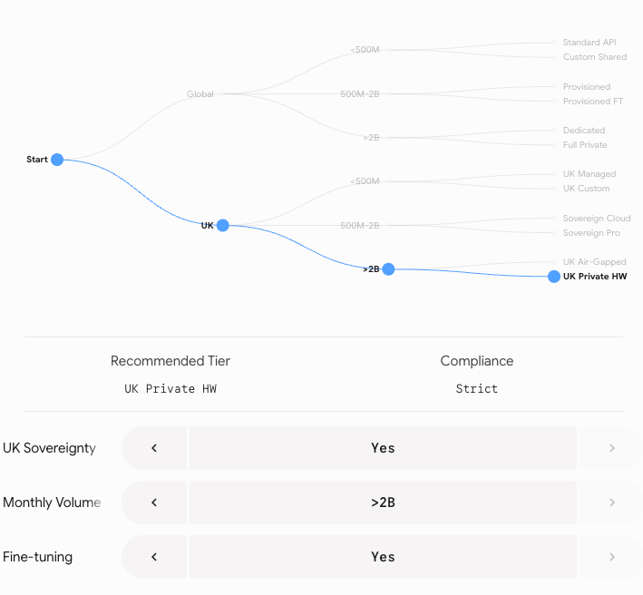

9.2 The Cloud IaaS Trap
Cloud IaaS is the worst-value option in this comparison, consistently 24–49% more expensive than PCAI across all three hyperscalers, while delivering:
- 5–12× longer time to production
- 3–4× higher engineering staffing requirement
- No included AI software stack, management, or support
- Committed spend billed during the build period
This is a counter-intuitive but well-documented finding. Cloud IaaS raw compute requires £169,000–£338,000 in additional engineering just to reach PCAI-equivalent capability — then £563,550 in ongoing lifecycle costs over 3 years. The Lenovo TCO whitepaper (2026 edition) concludes that on-premises infrastructure offers an "8× cost advantage per million tokens compared to Cloud IaaS".[^{6][}7]

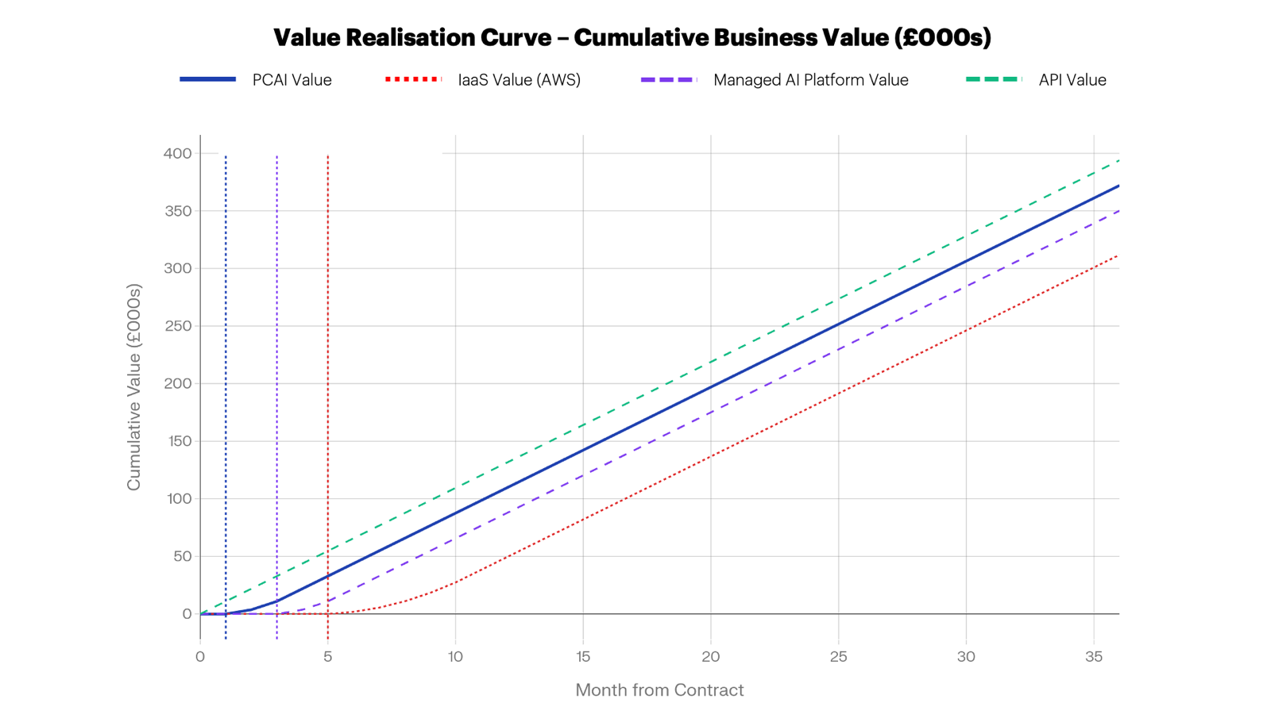

Section 10: Cloud Data Transfer Costs, Data Residency & Sovereignty

10.1 Data Transfer Costs: A Hidden Line Item in Cloud AI Deployments
Cloud data transfer pricing, commonly referred to as ingress and egress fees, rarely features prominently in vendor TCO proposals, yet for AI workloads that interact with enterprise data at scale, it can become a meaningful and unwelcome line item. This section is not intended as a detailed cost model; the transfer costs are very hard to predict / model and will be immaterial in some use cases and significant in others. The intent is to ensure that decision-makers are aware of the exposure before it appears on an invoice.

10.2 The structural reality of enterprise data in 2026
Most enterprise data doesn’t reside in the cloud. Current estimates indicate that 80–93% of enterprise data exists in unstructured formats, and a substantial proportion of this, documents, emails, logs, CAD files, clinical records, ERP extracts, and similar assets, continues to reside on-premises in structured databases, NAS arrays, and legacy storage systems. A 2025 Komprise study found that 74% of enterprises now store more than 5 petabytes of unstructured data, a 57% increase over 2024. By 2025, approximately 50% of all data worldwide is stored in the cloud — which implies the other 50% is not.
For an AI inference or RAG pipeline to operate effectively, it must be able to reach the data it needs to reason over. Where the processing engine and the data reside in different environments, data must move — and that movement has a cost.

10.3 What egress costs
The three major hyperscalers apply tiered outbound data transfer pricing. As of 2026, internet egress rates in EU/UK regions are approximately:
- AWS: $0.090/GB (first 10 TB/month), stepping down to $0.050/GB above 150 TB
- Azure: $0.087/GB (first 10 TB/month), stepping to $0.050/GB above 150 TB
- GCP: $0.085/GB (first 10 TB/month), stepping to $0.044/GB above 150 TB
Ingress is free across all three providers. Cross-region transfer within a provider adds $0.02–0.08/GB depending on origin and destination. The first 100 GB/month of egress is free across all three.
These figures are not alarming in isolation. A workload retrieving 500 GB/month from on-premises storage into a cloud AI platform incurs roughly $45/month — negligible. However, at enterprise AI scale — where RAG pipelines may retrieve many gigabytes per inference session across thousands of daily queries, or where model fine-tuning ingests terabytes of proprietary training data — the aggregate exposure grows quickly. Digital Signet's 2026 UK Cloud Egress benchmark notes that UK enterprises routinely underestimate their egress exposure by a factor of two to four at budget time, and that AI workload data movement is now the fastest-growing component of cloud bills for organisations running production AI features.

10.4 Weighting the impact across the options analysed in this report
The transfer cost exposure is not uniform across the platforms evaluated. Broadly:
Platform Category | Data Transfer Exposure | Notes
On-Premises AI Platforms (PCAI, DIY, Reference Arch, etc) | Minimal to zero | Data processing occurs on-site; no network boundary crossed for on-premises data
Cloud IaaS (AWS, Azure, GCP) | Moderate to significant | On-premises data must egress to cloud for processing; model outputs and retrieved context must return
Cloud-hosted API services | Low to moderate | Typically, prompt/response only; large document ingestion for RAG adds exposure
Hybrid RAG architectures | Variable | Depends on where the vector index and source documents reside

For the Cloud IaaS option specifically, which the main report already identifies as the most engineering-intensive and ultimately most expensive option at the scale modelled, data transfer costs add a further unpredictable tail. An enterprise whose source data is predominantly on-premises (which, per the statistics above, describes most organisations) will incur some data transfer costs every time that data is retrieved & returned for inference, summarisation, or retrieval-augmented generation. This cost does not appear in any hyperscalers standard AI pricing sheet.
The on-premises options, both PCAI and DIY, eliminate this exposure entirely by co-locating compute and data. This is a meaningful but often uncounted advantage.

10.5 Data residency, sovereignty, and intellectual property
Beyond cost, data movement into cloud environments raises compliance obligations that are particularly acute for UK-domiciled organisations. Under UK GDPR (retained from EU GDPR post-Brexit and administered by the ICO), any transfer of personal data to a third-party processor requires a compliant Data Processing Agreement, a Transfer Risk Assessment where data leaves the UK to a non-adequate jurisdiction, and documented Records of Processing Activities. These obligations apply regardless of whether the cloud provider's data centre is physically located in the UK; if support, maintenance, or sub-processing operations involve access from outside the UK, a transfer has occurred in the regulatory sense.
For regulated sectors, financial services under FCA oversight, healthcare under NHS Data Security Standards, or any organisation subject to MHRA or sector-specific data handling requirements, the question of where data is processed is not merely a cost consideration. It is a compliance prerequisite.
Processing sensitive data through a cloud-hosted AI API means that data traverses the provider's infrastructure, is potentially accessible to their engineering and support staff, and may be subject to foreign legal instruments such as the US CLOUD Act, which permits US government access to data held by US-headquartered cloud providers regardless of the physical server location.
Intellectual property is an equally important consideration. Proprietary documents, commercial contracts, formulations, source code, and strategic plans fed into a cloud-hosted AI model traverse infrastructure that the organisation does not control and cannot audit at the physical layer.
Even where contractual data processing agreements are in place, the practical enforceability of IP protection obligations against a hyperscaler is materially different from the protection afforded by on-premises processing where the data never leaves the organisation's own perimeter.
The on-premises deployment options, PCAI and DIY, resolve these questions by design.
Data processed on-site does not cross a cloud boundary, does not require a Transfer Risk Assessment, and is not subject to foreign legal instruments. For organisations where data sovereignty and IP protection are substantive requirements rather than compliance checkbox exercises, this is a structural advantage that does not appear in any TCO model but belongs in any complete evaluation.

Section 11: Appendices

Appendix A: Primary Source Data

Source | URL | Key Data Cited
HPE PCAI UK | hpe.com/uk/en/private-cloud-ai.html | "Go from AI idea to production in weeks"[^5]
HPE YouTube (Dec 2025) | youtube.com/watch?v=ByxS77nu2Ao | "In less than four weeks, you can have a pilot running"[^28]
MLCommons v5.0 | mlcommons.org/2025/04/mlperf-inference-v5-0results/ | Llama 2 70B highest submission rate test [^19]
MLPerf Results | infohub.delltechnologies.com | H200 NVL: 2,247 TPS/GPU server scenario [^18]
AWS EC2 Capacity Blocks | aws.amazon.com/ec2/capacityblocks/pricing/ | p5en (H200) $6.241/GPU/hr non-US [^30]
AWS p5en.48xlarge | calculator.holori.com | $63.296/hr on demand [^33]
GCP A3 High | spheron.network/blog/google-cloud-a3-h100pricing | $10.98/hr per GPU on demand [^31]
Azure ND H100v5 | spheron.network/blog/azure-h100-pricing | $12.29/hr per GPU on demand [^32]
Claude Pricing | platform.claude.com/docs/en/about-claude/pric ing | $2/$10 intro, $3/$15 standard post-Aug  2026[^41]
GPT-4o Pricing | pricepertoken.com | $2.50/$10.00 per 1M tokens [^42]
Gemini 2.5 Pro | finout.io/blog/gemini-pricing-in-2026 | $1.25/$10.00 per 1M tokens [^43]
AWS Bedrock Llama | go-cloud.io/amazon-bedrock-pricing/ | Llama 3.3 70B $0.72/$0.72 per 1M [^38]
Azure AI Foundry | futureagi.com | Llama 3.3 70B $0.71/$0.71 per 1M [^39]
GCP Vertex AI | custom.typingmind.com | Llama 3.3 70B $0.72/$0.72 per 1M [^40]
AWS S3 Pricing | finout.io/blog/cloud-storage-pricing | $0.023/GB/month standard [^37]
Azure Blob Pricing | nops.io/blog/azure-storage-pricing | $0.018/GB/month hot [^45]
GCP Storage | eon.io/blog/google-cloud-pricing | $0.020/GB/month standard [^46]
CBRE Data Centre 2025 | cbre.com/insights/reports | London: $180–$215/kW/month [^16]
AI/ML Engineer Salary UK | indeed.com | £111,975/yr average [^12]
Cloud Engineer Salary UK | itjobswatch.co.uk | £75,000 median senior [^13]
CIQ Infrastructure Cost | ciq.com/blog | 30–50% AI engineer time on infra work [^2]
gpucloudcost.com | gpucloudcost.com | 15–30% build cost of GPU-compute line [^1]
Rafay GPU idle | x.com/rafaysystemsinc | $100/GPU/day idle cost [^47]
Lenovo TCO 2026 | lenovopress.lenovo.com/lp2368 | 8× on-prem token cost advantage vs IaaS [^7]
datafi.co | datafi.co/blog | True 3yr TCO is 3–7× initial estimate [^7]
HMRC Full Expensing | PwC UK | 100% first-year allowance on plant & machinery [^8]
NVIDIA NIM Support Matrix | docs.nvidia.com/nim | Llama 70B ~131 GB GPU memory [^48]
NVAIE Licensing | docs.nvidia.com/ai-enterprise | Per-GPU licensing basis [^35]
UK Electricity Q4 2025 | glcg.co.uk | 25–26.3p/kWh commercial [^15]
H200 TDP | sunbirddcim.com | 700W TDP per H200[^29]
UK GDPR AI | ico.org.uk / aigovernance.com | DPIA mandatory for high-risk AI [^9]
AI Data Residency | aona.ai | UK GDPR transfer analysis requirements [^10]

Appendix B: Token Volume Calculation Workbook

Input Parameter | Value
Named users | 500
Peak concurrent users | 100
Average daily active users | 250 (50% of named)
Business hours | 08:00–18:00 GMT (10 hrs/day)
Sessions per user per day | 5
Input tokens per session | 2,500
Output tokens per session | 800
Total tokens per session | 3,300
Sessions per business day | 1,250
Tokens per business day | 4,125,000
Off-peak uplift | 10%
Total tokens per day | 4,537,500
Monthly token volume | ~109.4 million
Annual token volume | ~1,313 million
3-year token volume | ~3,939 million

Appendix C: Staffing Model

Platform | Role | FTE | Base Salary | +30% Oncosts | Annual  Cost
PCAI | ML/Platform Engineer (0.5 FTE) + Security  (0.25 FTE) | 0.75 | £95,000 | 1.30 | £92,625
Cloud IaaS | MLOps (0.75) + Cloud Infra (0.75) (app staff) | 1.5 | £90,000 | 1.30 | £175,500
Cloud IaaS | Platform lifecycle (Phase 3, avg. 1.7 FTE) | 1.7 | £85,000 | 1.30 | £187,850
Managed  Platform | Prompt eng. / cost gov / monitoring | 0.40 | £85,000 | 1.30 | £44,200
API Services | Prompt engineering / cost monitoring | 0.25 | £85,000 | 1.30 | £27,625

Appendix D: UK Colocation Benchmark Data

- London data centre rental: £155–£170/kW/month (CBRE 2025: $180–$215/kW) [^16]
- PCAI rack requirement: 1 × 42U rack, estimated 20–22 kW
- Annual CoLo cost: 22 kW × £155/kW/month × 12 = £40,920
- Cross-connects and networking: ~£3,600/year
- Note: UK CoLo market continues to tighten; availability constraints may push rates higher by 2027

Appendix E: MLPerf Benchmark
- MLPerf Inference v5.0 (April 2025): Introduced Llama 2 70B as highest submission rate benchmark; added Llama 3.1 405B [^{3][}19]
- 8-way H200 NVL: 2,247 tokens/sec/GPU server scenario (Llama 2 70B) — used as conservative 8-GPU throughput baseline [^18]
- CoreWeave GB200 vs H200: GB200 delivers 2.86× per-chip performance increase over H200 on Llama 3.1 405B [^23]
- Latency targets (MLPerf v5.0): 99th percentile TTFT 450ms; TPOT 40ms threshold for Llama2 70B interactive [^3]

Appendix F: FX and Discount Rate Assumptions

Parameter | Value | Justification
USD/GBP rate | £0.79 | July 2026 indicative; mid-market
Sensitivity range | ±10% | £0.71–£0.87
HMT Green Book discount | 3.5% | Standard public sector rate
NPV horizon | 3 years | Matching PCAI commitment term

Appendix G: Storage Allocation Detail

PCAI Internal Storage (~4 TB consumed, ~105 TB free headroom):
The total platform-internal consumption of the 109 TB is approximately 3–9 TB depending on deployment configuration. The RAG workload itself at Year 1 adds 0.4–1.2 TB. Total Year 1 consumption: ~3.5–10 TB. Remaining ~99–105 TB is available for expansion.
Cloud storage comparison: The RAG workload grows from ~0.4–1.2 TB (Year 1) to ~1.2–3.5 TB (Year 3). At S3 standard rates ($0.023/GB/month), 3-year total cloud storage cost is approximately £4,145 — compared to £0 incremental storage cost on PCAI.[^{36][}37]

Appendix H: Platform Build Cost Work Breakdown Structure

Phase | Work Stream | Mid Engineer-Days | Cost @ £1,000/day
Phase 1 | GPU provisioning | 3.5 | £3,500
Phase 1 | CUDA/driver installation | 7.5 | £7,500
Phase 1 | GPU Operator / K8s | 4.0 | £4,000
Phase 1 | Managed K8s cluster | 7.5 | £7,500
Phase 1 | Storage setup | 10.0 | £10,000
Phase 1 | Container registry / IAM | 4.0 | £4,000
Phase 1 | NIM deployment | 7.5 | £7,500
Phase 1 | Inference tuning | 7.5 | £7,500
Phase 1 Total |  | 51.5 days | £51,500
Phase 2 | RAG pipeline | 22.5 | £22,500
Phase 2 | Vector DB | 7.5 | £7,500
Phase 2 | Embedding serving | 5.0 | £5,000
Phase 2 | API gateway / auth | 7.5 | £7,500
Phase 2 | Observability | 7.5 | £7,500
Phase 2 | Security review | 10.0 | £10,000
Phase 2 | CI/CD | 7.5 | £7,500
Phase 2 | UI + integrations | 27.5 | £27,500
Phase 2 | Testing | 15.0 | £15,000
Phase 2 | Docs + training | 7.5 | £7,500
Phase 2 Total |  | 117.5 days | £117,500
TOTAL PHASE 1+2 |  | 169 days | £169,000

Phase 3 annual lifecycle: 1.7 FTE × £85,000 × 1.30 = £187,850/year × 3 = £563,550

Appendix I: Time-to-Value Model

PCAI Idle Capital Cost (4-week ramp-up):
- System hardware value: $1,800,000 × 72% hardware fraction = $1,296,000
- Straight-line depreciation: $1,296,000 ÷ (3 × 365) = $1,183/day
- 4 weeks idle = 28 days × $1,183 = $33,140 = £26,180

AWS IaaS Committed Idle Cost (16-week build):
- 3yr committed rate: ~$40.94/hr for 8× H200
- 16 weeks × 168 hours × $40.94/hr = $109,800 = £86,939
Net advantage of PCAI faster time-to-production: £86,939 − £26,180 = £60,759 lower idle capital cost

Value realisation gap (months 1–5):
- PCAI begins generating business value from Month 1
- Cloud IaaS begins from Month 5 (conservative; may be Month 9–13 in practice)
- At 109M tokens/month × £0.10/1,000 tokens value proxy = £10,940/month of deferred value
- 4-month gap = ~£43,760 in foregone business value (IaaS vs PCAI)

Appendix J: Glossary

Term | Definition
PCAI | HPE Private Cloud AI — turnkey on-premises AI platform
TCO | Total Cost of Ownership — all direct and indirect costs over the analysis period
NPV | Net Present Value — future costs discounted at 3.5% HMT Green Book rate
TTF | Time to First Inference — elapsed time from contract to first model response
TTP | Time to Production — elapsed time from contract to production-ready deployment
RAG | Retrieval-Augmented Generation — AI pattern using vector search to ground LLM responses
NVAIE | NVIDIA AI Enterprise — licensed software suite for GPU AI platforms
NIM | NVIDIA Inference Microservices — containerised LLM inference framework
HBM3e | High Bandwidth Memory 3e — GPU memory technology in H200 NVL
TPS | Tokens Per Second — LLM throughput metric
TTFT | Time to First Token — latency from query submission to first response token
TPOT | Time Per Output Token — inter-token latency for subsequent tokens
FTE | Full-Time Equivalent — staffing unit (1.0 FTE = one full-time person)
FX | Foreign Exchange rate (USD/GBP)
HMT | HM Treasury (UK government)
DPIA | Data Protection Impact Assessment (required under UK GDPR for high-risk AI)
DPA 2018 | UK Data Protection Act 2018
CAPEX | Capital Expenditure — upfront hardware/asset purchase
OPEX | Operational Expenditure — recurring subscription or service costs
CUD | Committed Use Discount (GCP's reserved instance equivalent)
CoLo | Colocation hosting / partner
MLPerf | Machine Learning Performance benchmark suite (run by MLCommons)
Report prepared July 2026. All pricing sourced from primary vendor documentation at date of research. Prices are subject to change; revalidation recommended before procurement decisions. FX rate of £0.79/USD should be refreshed at time of decision.

References
- How Much Can a GPU Cloud Save You? A Cost Breakdown vs On ... - We crunched the numbers: deploying 4x A100s on Runpod's GPU cloud can save over $124000 versus an on...
- The AI engineer era has an infrastructure problem. Here is ... - Organizations that run AI workloads on general-purpose infrastructure discover that the overhead is ...
- MLPerf Inference v5.0 Advances Language Model ... - MLCommons adds New Llama 3.1 405B Instruct and Llama 3.1 405B models to the MLPerf Inference v5.0 be...
- MLPerf Inference v5.0: New Workloads & New Hardware - Llama 2-70B Server:
Tokens/Sec/Accelerator Figure 1: Comparison of top Accelerator Results on Llama2...
- HPE Private Cloud AI | HPE Malaysia - Go from AI idea to production in weeks, not months, with turnkey private AI infrastructure built to ...
- Cloud or On-Prem for AI? The Cost Answer Most CIOs Get ... - For mature AI programs, hybrid architectures that blend on-premise cost efficiency with cloud flexib...
- On-Premise vs Cloud: Generative AI Total Cost of ... - This whitepaper analyzes the shifting economic landscape of Generative AI infrastructure in 2026, po...
- Full expensing - a new and valuable capital allowance - PwC UK - Effectively, the (now permanent) full expensing allowance means companies should receive up to a 25%...
- UK ICO Guidance on Artificial Intelligence and Data Protection - The UK ICO's guidance on AI and data protection establishes how the UK GDPR and Data Protection Act ...
- AI Data Residency Requirements for EU and UK Security Teams - This guide walks through the transfer rules at a working level, the UK's differences from the EU reg...
- AWS Slashes GPU Pricing for Nvidia H100, A100, and H200 Instances - Amazon Web Services (AWS) has announced substantial price reductions for accessing Nvidia's high-per...
- Senior AI/ML engineer salary in United Kingdom - Indeed - Cambridge. £171,942 per year · Boston.
£166,849 per year · Melbourne. £164,322 per year · Oxford. £1...
- Senior Cloud Engineer Job Trends, Salaries & Skill Sets - UK. The median Senior Cloud Engineer salary in the UK is £75,000 per year, according to job vacancie...
- Top Cloud Computing Careers by Salary in 2026 - Firebrand Training - According to Glassdoor, Cloud Consultant salaries of more senior levels in the UK vary between £60,0...
- What are the Current Business Electricity Rates in the UK? (2026) - Business – 26.3p/kWh – 40,000 kWh average annual electricity usage ... Current business electricity ...
- Global Data Center Trends 2025 | CBRE - London, Europe's largest data center market, had a rental rate range of $180 to $215 per kW per mont...
- NVIDIA H200 Price Guide 2026: GPU Cost, Rental & Cloud Pricing - NVIDIA H200 GPU costs
$30K-$40K to buy or $3.80/hr to rent. Compare H200 cloud pricing from AWS, Azu...
- MLPerf Results for the PowerEdge XE7745 Server with ... - In the Offline scenario, the PowerEdge XE7745 server achieves a throughput of 2112.51 tokens per sec...
- MLCommons Releases New MLPerf Inference v5.0 ... - With the v5.0 release, Llama 2 70B has now supplanted Resnet50 as the highest submission rate test. ...
- MLPerf Inference v5.0: Lambda's Clusters Prove Ready for ... - Throughput: Our optimized configurations on NVIDIA H200 delivered up to 13% higher tokens-per-second...
- Llama 3.3 70B very slow - vLLM Forums - Llama 3.3 70B should achieve much higher throughput than 40 tokens/sec on H200s with correct tuning ...
- NVIDIA NIM Support Matrix: Every Model × GPU × Profile - *Llama 3.3 70B: NVFP4+LoRA not available at TP1. Recommendation: Use vllm-fp8-tp2-pp1 on 2x A100 80G...
- CoreWeave Delivers Breakthrough AI Performance with ... - CoreWeave achieves top-tier performance in MLPerf Inference v5.0 with NVIDIA GB200 Grace Blackwell S...
- Announcing Llama 3.1 Support in vLLM - AMD MI300x or NVIDIA H200: vLLM can run the model on a single 8xMI300x or 8xH200 machine, where each...
- llama-3.3-70b-instruct Model by Meta | NVIDIA NIM - bf16, 138 GB, 180 GB. fp8, 69 GB, 90 GB.
Deploying this NIM with less than the ... llama-3.3-70b-ins...
- Llama-3.3-70B-Instruct GPU Requirements: VRAM & Cheapest GPU - To run Llama-3.3-70B-Instruct for inference at FP16, you need roughly 154 GB of VRAM. The cheapest f...
- HPE Private Cloud AI - Behind the Curtain - HPE Private Cloud AI is a co-developed scalable, preconfigured, AI-ready private cloud that gives A...
- Accelerating AI to Production with HPE Private Cloud AI - YouTube - AI's full potential is limited by unpredictable costs, data security, and complex custom builds. HPE...
- NVIDIA H200 Power Requirements: Can Your Racks Support Them? - The H200 Tensor Core GPU has a maximum Thermal Design Power (TDP) of 700W. This represents the maxim...
- Amazon EC2 Capacity Blocks for ML Pricing - AWS - Effective July 7, 2026, hourly rates per accelerator will be: P6-B300 at $14.04 (all available AWS R...
- Google Cloud A3 H100 Pricing 2026: GCP Per-Hour Cost ... - The full 8-GPU node is approximately $87.84/hr. Spot pricing is approximately $3.69/hr per GPU. A 1y...
- Azure H100 Pricing 2026: ND H100 v5 Per-Hour Cost Compared to ... - Azure ND H100 v5 costs $12.29/hr per GPU on-demand. Spheron H100 starts at $2.64/hr on-demand or $1....
- p5en.48xlarge pricing and specs - AWS EC2 Pricing - Holori - The p5en.48xlarge is a P5EN instance with 192 vCPUs and 2048 GiB of memory with 3200 Gigabit network...
- AWS quietly increases prices for H200 EC2 instances by 15% - DCD - The cuts came in June 2025, and saw the P4d (A100), P4de (A100), P5 (H100), and P5en (H200) getting ...
- NVIDIA AI Enterprise Licensing - NVIDIA AI Enterprise in cloud marketplaces is priced per GPU per hour on an on-demand/pay-as-you-go ...
- Understanding AWS S3 Storage Classes & Pricing - S3 Standard aws s3 pricing per gb follows a tiered model: First 50 TB/month: $0.023/GB. Next 450 TB/...
- Cloud & AI Storage Pricing Comparison 2026: AWS, Azure, ... - A 100 TB S3 Standard workload looks like $2,304/month on paper. Add 500M GET requests ($200), 50M PU...
- Amazon Bedrock Pricing 2026 | Compare AI Model Costs - GoCloud - Llama 3.3 70B Instruct, $0.00072, $0.00072. Meta, Llama 3.2 90B Vision, $0.002, $0.002. Meta, Llama ...
- Llama 3.3 70B Instruct - Azure AI Foundry - Future AGI - Input is priced at $0.710 per 1M tokens and output at $0.710 per 1M tokens (Azure AI Foundry, last v...
- Vertex Llama 3.3 70B Instruct API Pricing Calculator - It is priced at $0.7200/1M input tokens and $0.7200/1M output tokens. Key capabilities include: tool...
- Pricing - Claude Platform Docs - Introductory pricing of $2/$10 per million input/output tokens is in effect through August 31, 2026,...
- GPT 4o API Pricing 2026 - Costs, Performance & Providers - GPT 4o is priced at $2.50 per million input tokens and $10.00 per million output tokens. It has a co...
- Gemini Pricing in 2026 for Individuals, Orgs & Developers - Finout - Paid consumer plans run $19.99/month (Pro) or $124.99 for 3 months (Ultra). API access starts at $0....
- Complete Guide to Azure Blob Storage Pricing 2025-26 - Sedai - What you'll learn: How Azure Blob Storage tiers are priced: Hot costs $0.023/GB/month, Cool $0.013, ...
- Azure Storage Pricing in 2026: A Complete Breakdown of Costs ... - Azure Blob Storage vs. AWS S3:
Pricing Comparison (2026) ; Hot/Standard (first 50 TB), $0.018/GB, $0...
- Google Cloud Pricing 2026: Cost Breakdown & Hidden Costs - Eon.io - Cloud Storage starts at $0.020/GB-month for Standard regional and drops to $0.0012/GB for Archive, w...
- How GPU Idle Time Destroys AI Infrastructure ROI - Every GPU sitting idle costs you around $100 a day, and a six-month delay across a 512-chip fleet ad...
- Support Matrix — NVIDIA NIM for Large Language Models (LLMs) - Memory requirements vary greatly … 2 GB of memory Llama 8B: ~ 15 GB Llama 70B: ~ 131 GB. Disk Space ...

On-Premises DIY vs HPE Private Cloud AI: TCO & ROI Analysis
Report Date: July 2026
Basis: 500-user enterprise LLaMA 3.3 70B inference deployment, UK-domiciled, GBP throughout. USD converted at 1 USD = £0.79. Directly comparable to the HPE PCAI Gen2 Medium vs “Cloud AI” analysis in the preceding TCO report.

Executive Summary
A DIY on-premises build centred on an 8× NVIDIA H200 NVL PCIe server is cheaper than HPE PCAI Gen2 Medium on a narrow cash-outflow-only TCO basis (base case: £1,366,836 vs £1,938,435 — 29.5% cheaper). However, this comparison is economically misleading. When the full economic cost is applied — incorporating idle capital depreciation during the build phase, colocation costs during the unproductive period, and foregone business value during the 9–14-month time-to-production gap — PCAI becomes the superior economic choice once the system generates more than approximately £23,000/month in business value.

The 2026 GPU supply crisis fundamentally transforms this comparison. H200 NVL hardware carries 36–52-week lead times for independent procurement, meaning a DIY order placed today will not receive hardware until mid-2027 at the earliest. HPE, as a Tier-1 NVIDIA supply chain partner with forward allocation agreements, delivers PCAI in approximately 6-12 weeks. The compounded effect of procurement delay plus build time pushes DIY's realistic time-to-first production-token to 18–24 months from order — against PCAI's 12–15 weeks.[^{1][}2][^{3][}4]
This is the decisive finding of this analysis. At any meaningful valuation of business value foregone during an 18–24 month zero-productivity period, the DIY option is not a cheaper alternative — it is a categorically different risk profile that is difficult to justify for a 500-user production AI deployment in 2026.
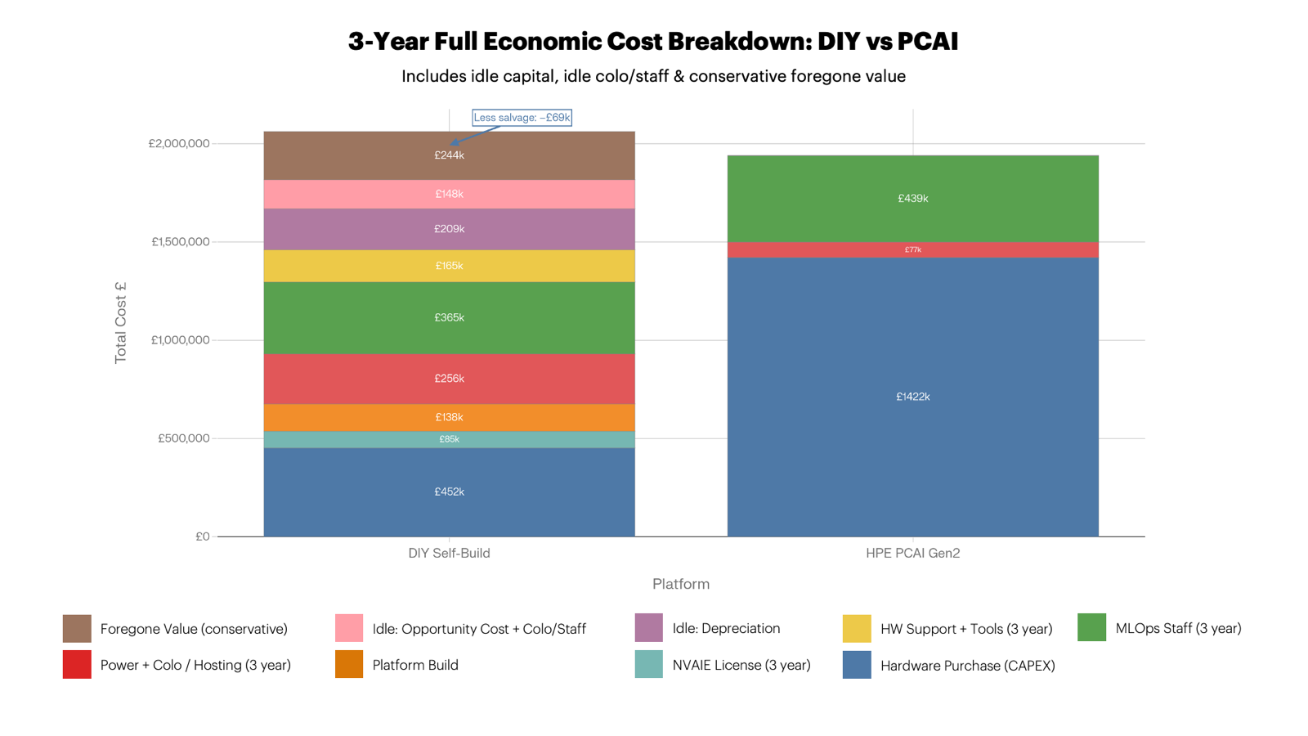

Section 1: The 2026 GPU Supply Crisis — Structural constraint, not a Market Blip

1.1 Root Causes
The H200 NVL GPU shortage is not a temporary procurement issue. It is a structural supply constraint with at least two independent binding bottlenecks, neither of which will resolve before (realistically) mid-2027:[^{1][}2]

Bottleneck 1: CoWoS Packaging Capacity
NVIDIA's H200 (and all HBM-equipped data centre GPUs) require TSMC's Chip-on-Wafer-on-Substrate (CoWoS) advanced packaging process to bond HBM3e dies onto the GPU substrate. CoWoS capacity at TSMC is fully allocated through at least mid-2027. Current demand exceeds supply by a factor of 1.4× to 1.6× — a gap that is expected to persist for 18–24 months from today. TSMC is aggressively expanding CoWoS capacity, but the manufacturing expansion itself has a multi-year lead time.[^{2][}1]

Bottleneck 2: HBM3e Memory Supply
The H200's 141 GB HBM3e is produced exclusively by SK Hynix, Samsung, and Micron. All three suppliers are at full allocation through Q4 2026 at minimum. SK Hynix is NVIDIA's primary HBM3e supplier; their capacity is fully committed to NVIDIA's data centre GPU roadmap through 2026. Samsung and Micron are ramping HBM3e production, but meaningful new capacity is not expected to reach the market before late 2026 to early 2027.[^{1][}2]

Bottleneck 3: Hyperscaler Pre-emption
Microsoft, Google, Meta, and Amazon placed multi-billion-dollar forward orders for Blackwell GPUs (GB200, B200) in 2025, consuming most of NVIDIA's available allocation capacity through the end of 2026 and into 2027. This has systematically crowded out mid-market and enterprise buyers who purchase through standard channels or direct resellers. Chinese enterprises have placed orders for over 2 million H200 units for 2026 delivery, compounding global allocation pressure.[^{5][}1]

Bottleneck 4: H200 Scheduled End of Life
Viperatech reports H200 at scheduled EOL from April 2026, with 30%+ price increases already observed in secondary channel. H100 is officially out of production. The practical implication: remaining H200 inventory is being absorbed by customers with existing allocation relationships — primarily HPE, Dell, and the hyperscalers — leaving the open market extremely thin. [^6]

1.2 Current Lead Time Reality

Procurement Route | H200 NVL Lead Time (July 2026) | Notes
Open market / reseller (DIY) | 36–52 weeks | Spheron: structural shortage, CoWoS and HBM3e constrained [^1]
Large-volume reseller | 30–50 weeks | SiliconAnalysts: "new normal for large-volume orders"  [^2]
Spot market premium | 12–20 weeks at 30–50% price premium | If allocation available at all [^{7][}8]
Fusion Worldwide / broker | 3–7 months (13–30 weeks) [^8] | Availability highly inconsistent week-to-week [^7]
HPE PCAI (integrated system) | ~12 weeks | HPE supply chain priority, factory pre-integrated [^{4][}3]

The lead time differential alone — 36–52 weeks for DIY vs ~12 weeks for PCAI — represents a 24– 40-week gap before a single GPU is racked, powered on, or validated. This is before any engineering work begins.
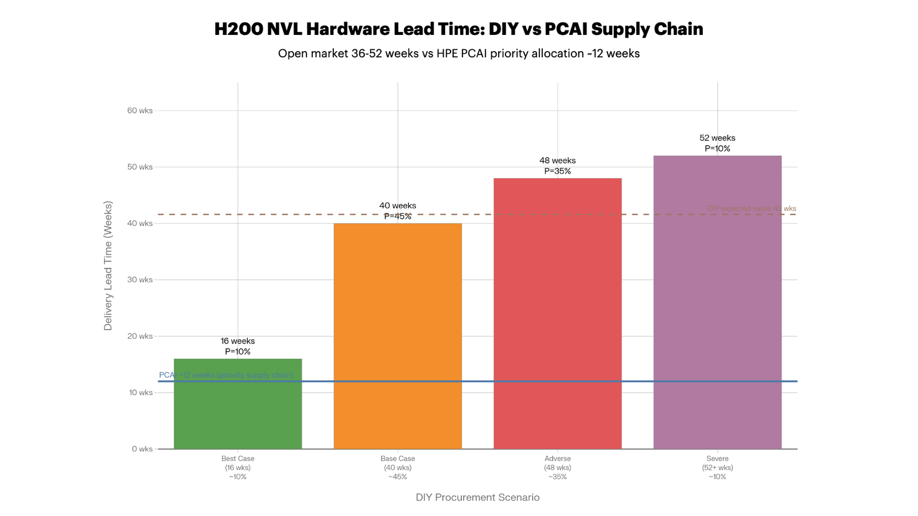

1.3 Why HPE Has Priority Allocation
HPE occupies a structurally different position in the NVIDIA supply chain than an enterprise buying through a reseller:
- NVIDIA AI Computing by HPE is a formal joint initiative between the two companies, announced at GTC 2025, creating a co-engineering and supply chain prioritisation relationship [^9]
- HPE factory-integrates PCAI systems at the point of manufacture, meaning GPU allocation is secured at the production level — not the distribution level [^{4][}10]
- HPE's forward purchase agreements for NVIDIA hardware span multiple product generations, giving them committed allocation that independent buyers cannot access [^9]
- The PCAI system ships as a complete, validated, factory-integrated unit — meaning HPE's supply chain commitment covers the entire stack (GPU, server, networking, storage) as a single SKU, not as individually sourced components [^10]
Centerprise Cloud UK (HPE partner) confirms: "PCAI enables rapid deployment and can be fully operational within a day [of physical delivery], over 6–8 weeks [from order to delivery] with full support". For this analysis, the conservative 12-week order-to-delivery figure is used. [^3]

Section 2: Time-to-Production Comparison — The Full Picture

2.1 Realistic Timeline Modelling
The single most important variable in this comparison is not hardware cost or OPEX — it is the duration of the period from order placement to first production AI token served. Every day in this gap represents capital deployed but not working.

DIY Timeline (2026 Reality)

Phase | Duration | Notes
Order to hardware delivery | 36–52 weeks | Open market H200 NVL lead time [^{1][}2]
Hardware receipt and rack build | 2–3 days | Physical installation, cabling, PDU
NVIDIA NVVS validation | 3–5 days | GPU drivers install, validation suite, 8× GPU diagnostic pass/fail/remediation [^11]
OS hardening and CUDA stack | 3–5 days | RHEL/Ubuntu enterprise, CIS benchmarks, CUDA 12.x, driver pinning [^12]
Kubernetes + GPU operator | 4–6 days | K8s cluster, NVIDIA GPU operator, MIG config, resource quotas
400GbE networking config | 3–5 days | Switch config, RoCEv2/PFC/DCQCN tuning, ECMP, jumbo frames  [^13]
Storage integration | 2–3 days | CSI driver, 62TB array, PVC provisioning, I/O benchmarking
NIM / vLLM deployment | 3–5 days | NVAIE auth, NIM microservice, model pull (~138GB BF16), vLLM config [^14]
RAG pipeline integration | 4–7 days | Vector DB, embedding pipeline, document ingestion, API gateway
Monitoring and observability | 3–4 days | DCGM Exporter, Prometheus, Grafana, alerting, SIEM
Security hardening | 3–5 days | RBAC, network policies, secrets management, container scanning, audit logging
Integration and load testing | 4–6 days | End-to-end testing, failover, latency/throughput benchmarking
72-hour burn-in | 3 days (calendar) | Standard enterprise GPU commissioning [^12]
Remediation buffer | 5–15 days | Driver incompatibilities, NUMA issues, storage IOPS surprises (first-time deployment)
Documentation and UAT | 6–10 days | Runbooks, DR procedures, user acceptance sign-off
Total post-delivery build | ~50–80 engineer days | ~10–16 calendar weeks for a dedicated team
TOTAL: Order to  Production | ~48–68 weeks | ~12–17 months

A dedicated and competent internal team — not a specialist firm doing this daily — will realistically take 10–16 calendar weeks post-delivery to reach a production-stable, security-hardened, UAT-signed-off system. Petronella Technology (GPU server specialists who do this routinely) document a six-phase process taking 4–8 weeks for their own engineers; an internal team doing this for the first time should budget at least double that. The 72-hour burn-in alone is a mandatory step that consumes 3 calendar days regardless of team size. [^12] Realistic DIY order-to-production: 12–17 months from order date.

HPE PCAI Timeline

Phase | Duration | Notes
Order placement and configuration | 1–2 weeks | Spec confirmation, contract execution
Factory integration and test | 6–8 weeks | HPE factory validates full stack before shipping
Physical delivery to UK site | 1–2 weeks | Freight and logistics
Rack installation and powerup | Hours | Pre-cabled, validated rack unit [^{10][}3]
NVIDIA AI Essentials initialisation | Hours | Pre-loaded software stack, GreenLake onboarding [^4]
First model serving (NIM) | Same day or next day | Documented customer case: production chatbot live within 5 hours of delivery [^10]
TOTAL: Order to  Production | ~10–14 weeks | Conservative: 12 weeks

HPE's "use case to production in weeks, not months" claim is substantiated by partner documentation. Centerprise confirms "fully operational within a day" of physical delivery. The 12-week figure used here is the conservative end of the observed range.[^{3][}4] [^15]

2.2 The Timeline Gap: Visualised
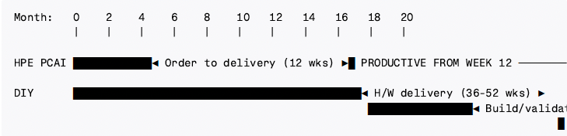
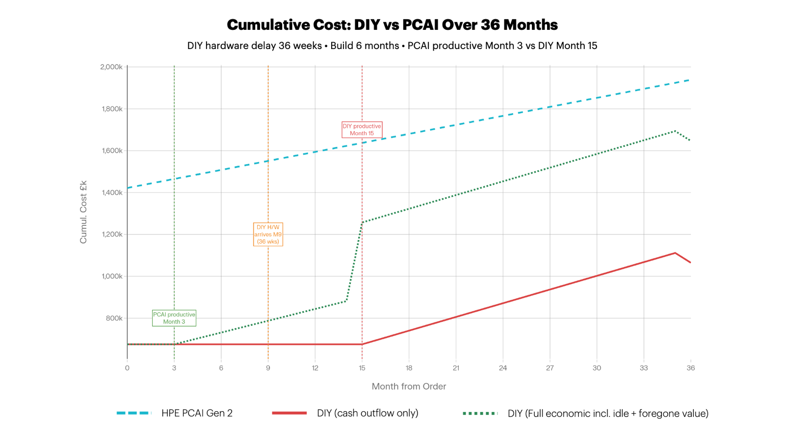
The gap between PCAI's first productive month (~Month 3) and DIY's first productive month (~Month 15–17) is 12–14 months of zero return on committed capital.

Section 3: The True Economic Cost of the DIY Timeline Gap

3.1 Capital Committed on Day Zero
The DIY approach requires placing a purchase order for hardware and licensing upfront — or at minimum, committing capital to a deposit. For the purposes of this model, the full DIY CAPEX commitment of £537,672 is treated as deployed from order date (Month 0), consistent with standard enterprise procurement practice.
During the period from order to production (12–17 months), this capital:
- Earns no return from the AI system
- Depreciates (assets begin amortising from delivery, not from productive use)
- Incurs colocation costs from the point hardware is racked
- Represents an opportunity cost against alternative capital deployment

3.2 Idle Capital Cost Breakdown
Using the conservative 14-month order-to-production timeline as the central estimate (36-week hardware delivery + 12 weeks build/validate):

Cost Category | Calculation | Total
Opportunity cost of capital | £537,672 × 5% WACC × (14/12) months | £31,364
Depreciation during idle period | £537,672 ÷ 36 months × 14 months idle | £209,096
Colocation during build phase (hardware racked from month 9 onwards, 5 months idle) | £85,281/yr × (5/12) | £35,534
Engineering staff during hardware wait (team hired in Month 8, platform planning, pre-work) | £121,275/yr × (8/12) | £80,850
Total idle capital cost |  | £356,844

The depreciation figure deserves particular attention: £209,096 of asset value is consumed before the system generates a single pound of return. This is not a cash outflow — it is destruction of capital value, and it does not appear anywhere in a traditional cash-outflow-only TCO model. Any business case presented to a CFO or finance committee must account for it.
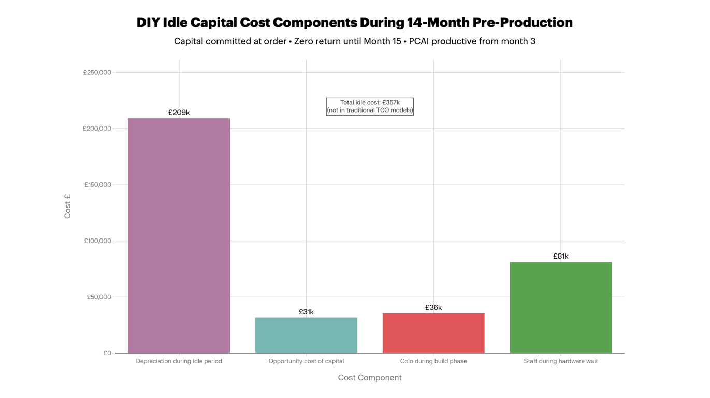

3.3 Foregone Business Value
This is the dominant economic cost and the one most frequently omitted most TCO comparisons. PCAI begins generating value from approximately Week 12 (Month 3). DIY begins generating value from approximately Month 15–17. The gap is 12–14 months of business value not realised.
The value foregone depends on the specific business use case. Three scenarios are modelled:

Scenario | Monthly Value Basis | Monthly Value | 13-Month Gap Cost
Conservative | Productivity uplift only: 500 users × 30 mins/day saved × £30/hr | ~£18,750 | ~£244,000
Base Case | Productivity + workflow automation + IT cost displacement | ~£50,000 | ~£650,000
Commercial | Revenue-generating AI product or client-facing automation | ~£100,000+ | ~£1,300,000+

Even the conservative scenario — which values 500 users saving just 30 minutes per day at an average cost rate of £30/hour — produces £244,000 in foregone value over a 13-month gap. This is not a stretch assumption; it is the lowest reasonable floor for a 500-user enterprise AI deployment with a justified business case.

Section 4: Revised Three-Year TCO — Full Economic Model

4.1 Cost Stack (Unchanged from Prior Analysis)

Cost Category | DIY Self-Build | HPE PCAI Gen2
Hardware CAPEX (server, networking, storage, integration) | £452,352 | £1,422,000
NVIDIA AI Enterprise (3-year) | £85,320 | Included
Platform Build Cost (engineering) | £125,000–£145,000 | £0.00
Power + Colocation (3yr productive period) | £255,843 | £77,112
MLOps Staff (3yr, 1.0 FTE) | £363,825 | ~£439,323
HW Support Contracts (3yr) | £54,282 | Included
AI Networking Fabric (100+ GbE) | £0.00⁴ | Included (400 GbE)⁴
Software / Monitoring Tools (3yr) | £45,000 | Included
Admin Overhead (3yr) | £65,769 | Included
Salvage Credit (Year 3) | –£68,730 | £0.00
Subtotal: Cash-Outflow TCO | ~£1,378,661 | £1,938,435

4.2 Full Economic TCO Including Idle Capital and Foregone Value

Additional Economic Cost | DIY | PCAI
Idle capital depreciation (14-month preproduction) | £209,096 | £0
Opportunity cost of capital (14 months) | £31,364 | £0
CoLo + staff during hardware wait/build | £116,384 | £0
Foregone business value — Conservative | £244,000 | £0
Foregone business value — Base Case | £650,000 | £0
Scenario | DIY Full Economic TCO | PCAI TCO | DIY vs PCAI
--- | --- | --- | ---
Cash outflow only (traditional model) | £1,378,661 | £1,938,435 | DIY –28.9% cheaper
+ Idle capital costs (no foregone value) | £1,735,505 | £1,938,435 | DIY –10.5% cheaper
+ Conservative foregone value | £1,979,505 | £1,938,435 | DIY +2.1% more expensive
+ Base case foregone value | £2,385,505 | £1,938,435 | DIY +23.0% more expensive

The crossover point — where DIY and PCAI break even on full economic TCO — occurs when foregone business value exceeds approximately £21,000/month over the 13-month gap. This is a remarkably low threshold: it equates to roughly 500 users saving just 28 minutes per day at a blended rate of £28/hour. For any enterprise AI deployment with a justifiable business case, this threshold will have been cleared before the procurement decision was made.
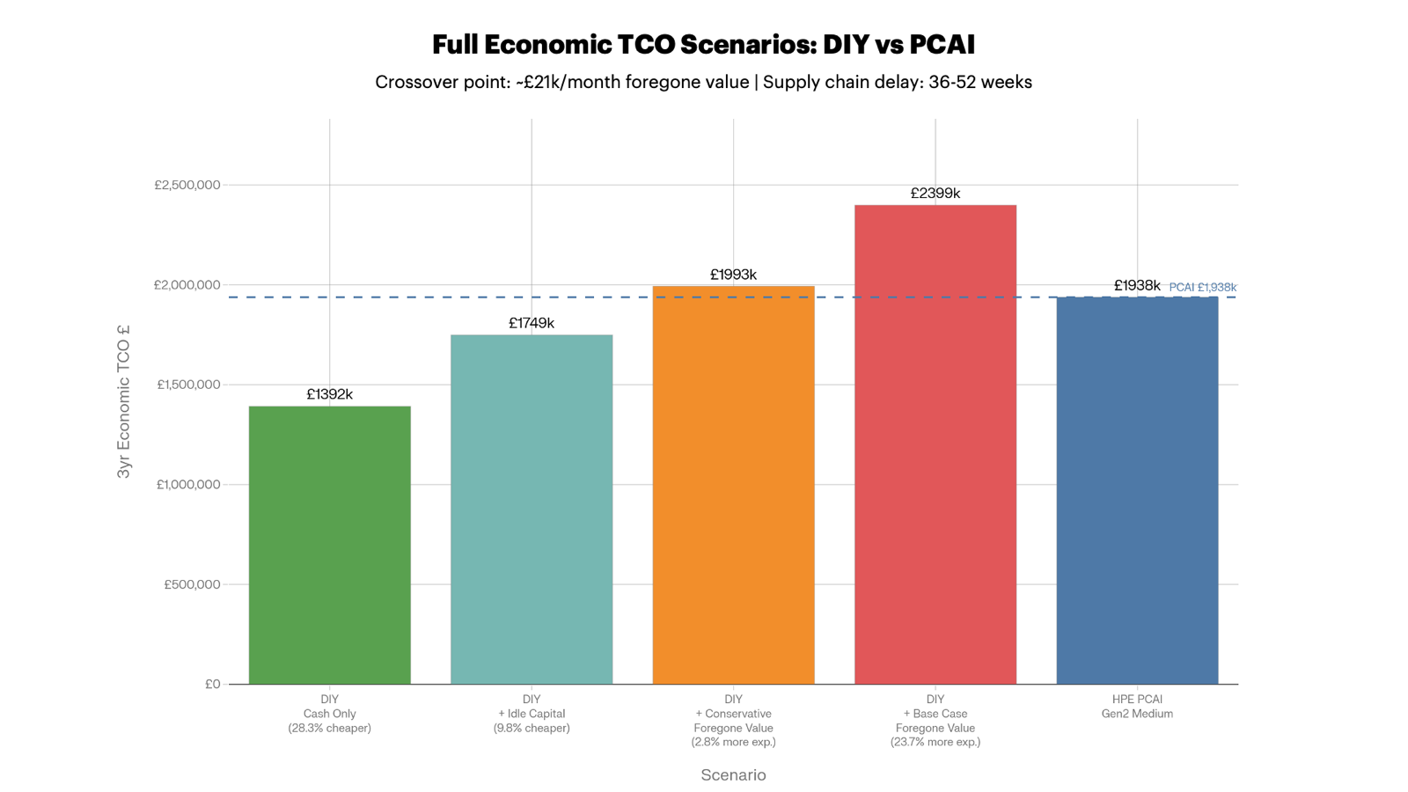

4.3 Effective Cost Per Million Tokens (Full Economic Basis)

Platform | Full Economic TCO | GPU Utilisation | Effective £/1M Tokens
DIY (cash outflow only, 85% util) | £1,378,661 | 85% | £3.39
DIY (+ idle capital, 85% util) | £1,735,505 | 85% | £4.27
DIY (+ conservative foregone value) | £1,979,505 | 85% | £4.87
DIY (+ base case foregone value) | £2,385,505 | 85% | £5.87
HPE PCAI Gen2 | £1,938,435 | 85% | £4.13
AWS Bedrock API | ~£150,000 | N/A | £0.57
On a full economic basis, DIY is only cheaper than PCAI if foregone value is excluded entirely or valued below ~£21,000/month — a position that is very difficult to sustain in a business case context.

Section 5: Supply Chain Risk Modelling

5.1 Scenario Analysis: Hardware Lead Time Outcomes
Given the structural nature of the 2026 GPU shortage, the DIY procurement outcome is not a single point estimate — it is a probability distribution. The following scenarios reflect documented market conditions:

Scenario | Probability | H200  Delivery | Build  Time | Production  Start | Total Gap (from order)
Best case (existing reseller allocation, spot market premium paid) | ~10% | 16 weeks | 12 weeks | Month 7 | ~7 months
Base case (open market procurement, standard reseller) | ~45% | 36–44 weeks | 14 weeks | Month 14–16 | ~14–16 months
Adverse case (allocation constrained, queue position) | ~35% | 44–52 weeks | 16 weeks | Month 17–19 | ~17–19 months
Severe case (H200 EOL stock exhausted,  B200 required) | ~10% | 52+ weeks | 18 weeks | Month 20+ | ~20+ months

*Probability estimates based on: Spheron 36–52-week lead time; Fusion Worldwide 3–7-month range; SiliconAnalysts "30–50 weeks new normal"; Viperatech H200 EOL risk *[^{1][}6][^{2][}8]
Expected value of DIY hardware delivery delay (probability-weighted):

The probability-weighted expected time from DIY order to production is approximately 15.7 months — meaning the base-case 14-month estimate used in this analysis is slightly optimistic.

5.2 Price Risk During DIY Lead Time
The 2026 supply shortage introduces significant price volatility risk for DIY procurement:
- Electropages documents vendors shortening price quote validity down to 24–48 hours (HPE currently honours 30-day price validity on PCAI system quotes) in the current market [^16]
- H200 spot market prices are 30–50% above list for any available allocation [^{6][}2]
- The remediation for a DIY buyer who cannot secure H200 NVL is to either pay spot premium or wait for B200/Blackwell availability — which carries its own 14–26-week lead time [^6]
- A DIY buyer who locks in pricing at order may find the hardware price has risen materially by the time they reach the front of the queue
- HPE and many other vendors have seen month-on-month price increases of 10–20% in 2026 for some components and systems
HPE PCAI pricing is fixed at contract signature — the factory-integrated nature of the system means HPE absorbs supply chain price risk within their forward allocation model. This is a non-trivial risk transfer benefit that has no direct cash value but protects the budget from material overrun. [^16]
This is also true if PCAI is purchased as a service, using the HPE GreenLake transaction vehicle, where the UoM price is fixed at contract signature and remains unchanged for the duration of the contract.

5.3 The Procurement Risk Comparison

Risk Factor | DIY | HPE PCAI
Hardware delivery certainty | Low — 36–52-week range, allocation not guaranteed [^1] | High — HPE priority allocation, ~12-week commitment [^{4][}3]
Price lock | None — 24–48 hr quote validity [^16] | Fixed at contract signature
H200 EOL risk | High — stock depletion accelerating [^6] | Mitigated — HPE forward allocation secures supply
Component substitution risk (if H200 unavailable) | Full — must re-specify, re-budget | None — HPE manages internally
Budget overrun risk | Material | Low
Delivery slip consequence | Extends zero-productivity period by weeks/months | Weeks of tolerance in project schedule

Section 6: Platform Build Cost
The platform build cost is broken down by engineering discipline:

Work Package | Engineer-  Days | Role | Cost (£)
Hardware installation and racking | 5 days | Senior Engineer | £1,825
NVIDIA NVVS GPU validation (8 GPUs) | 5 days | Senior Engineer + Architect | £4,135
OS hardening, CUDA stack, driver management | 5 days | Senior Engineer | £1,825
Kubernetes cluster + GPU operator | 6 days | Senior Engineer | £2,190
400GbE networking fabric configuration | 5 days | Senior Engineer + Architect | £4,135
Storage CSI integration and benchmarking | 3 days | Senior Engineer | £1,095
NVIDIA NIM / vLLM deployment and tuning | 5 days | Senior Engineer | £1,825
RAG pipeline (vector DB, embedding, ingestion) | 7 days | Senior Engineer | £2,555
Monitoring, DCGM, Grafana, SIEM | 4 days | Senior Engineer | £1,460
Security hardening, RBAC, audit logging | 5 days | Senior Engineer | £1,825
72-hour burn-in test and observation | 3 days | Senior Engineer | £1,095
Integration and load testing (500-user scale) | 6 days | Senior Engineer | £2,190
Remediation buffer (15% contingency) | 9 days | Senior Engineer | £3,285
Documentation, runbooks, DR procedures | 5 days | Senior Engineer | £1,825
User acceptance testing and sign-off | 5 days | Senior Engineer + Architect | £4,135
Project management and coordination | 8 days | Architect | £3,696
Subtotal engineering | ~86 days |  | £38,901
Fully loaded multiplier (1.35×: NI, pension, benefits) |  |  | £52,516
Platform build total |  |  | ~£130,000–£145,000

PCAI equivalent: £0 — the AI Essentials stack is pre-installed, integrated and tested / validated before the rack leaves HPE's factory.[^{4][}17]

Section 7: Hardware and Architecture Comparison

7.1 Technical Equivalence
At the GPU level, the DIY and PCAI systems are functionally equivalent for the inference workload modelled. The H200 NVL PCIe at 600W TDP and 141 GB HBM3e fits LLaMA 3.3 70B BF16 in a single GPU's VRAM, making NVSwitch interconnect unnecessary for this specific workload. Performance at the GPU level will be identical.[^{18][}19] [^20]

Dimension | DIY (Supermicro SYS-821GE-TNHR) | HPE PCAI Gen2 Medium
GPU | 8× H200 NVL PCIe, 141 GB HBM3e | 8× H200 NVL, validated
Total VRAM | 1,128 GB | 1,128 GB
CPU | Dual Xeon 4th/5th Gen | HPE ProLiant Gen12
Memory | 2 TB DDR5 | 2 TB DDR5
Storage | 62 TB third-party NVMe | 62 TB Alletra X10000 / 109 TB GreenLake for File Storage
Networking | 400GbE (self-configured) | NVIDIA Spectrum-X validated
Form factor | 8U, self-racked | Pre-cabled integrated rack
Delivery | 36–52 weeks [^1] | ~12 weeks [^{4][}3]
Production ready | 12–17 months from order | 12–15 weeks from order

7.2 Software Stack

Layer | DIY | HPE PCAI
Inference server | vLLM / TensorRT-LLM (self-built) [^21] | NVIDIA NIM (validated, supported) + HPE MLIS
Orchestration | Kubernetes (self-managed) | HPE GreenLake + K8s (managed)
Model registry | MLflow / custom | NVIDIA Model Registry
Monitoring | Self-built (Prometheus + Grafana) | AIOps on GreenLake
NVIDIA Blueprints | Manual implementation required | Pre-loaded (AI-Q, RAG, agentic) [^17]
Additional Tools / Frameworks | Yes. Although manual deployment, integration, security wrapping and validation / testing is required | K8S tools and frameworks (open source or proprietary) are importable via HELM deployment
Security patching | Manual, engineer-dependent | HPE Engineering / Services managed via software update mechanism
Support SLA | NVAIE only (software) – via NVIDIA direct | Full-stack HPE support (HW, SW, Models)
Upgrade lifecycle | Manual — version pinning risk | HPE managed / distributed
Vendor accountability | Fragmented (“HW vendor” + NVIDIA + community) | Single vendor (HPE)

Section 8: Pros, Cons, and Decision Framework

On-Premises DIY

8.1 DIY Advantages
- Lower hardware CAPEX: £452,352 vs £1,422,000 — a £969,648 CAPEX delta before operational costs
- Hardware and vendor flexibility: Choice of server, storage, networking; not locked into HPE's configuration or GreenLake management plane
- Open-source inference stack: vLLM supports NVIDIA, AMD, and Intel hardware — no platform lock-in for future GPU generations [^23]
- Full control over firmware and configuration: Independent upgrade cadence, bespoke security configuration
- Lower 3-year cash-outflow TCO at ≥70% GPU utilisation: £1,378,661 vs £1,938,435 (28.9% cheaper on cash basis)
- Higher residual asset value optionality: GPU resale market for H200 is liquid; residual credit of ~£68,730 at Year 3

8.2 DIY Disadvantages
- 36–52-week hardware lead time in 2026: No guaranteed allocation; queue position uncertain [^{1][}2]
- H200 EOL risk: Scheduled EOL with 30%+ price increases; remaining stock being absorbed by priority customers [^6]
- Price volatility risk: 24–48-hour quote validity; spot market premium of 30–50% if standard allocation exhausted [^{7][}16]
- 12–17 months to production from order: The dominant economic disadvantage — zero return on £537,672 of committed capital for over a year
- £356,844 in idle capital costs: Depreciation, opportunity cost, and CoLo/staff during unproductive period
- £244,000–£650,000 in foregone business value: Even at conservative assumptions, the time to-value gap costs more than the hardware CAPEX saving
- Platform build of £130,000–£145,000: Engineering cost that PCAI eliminates entirely
- No integrated full-stack support: Cross-vendor troubleshooting (Supermicro + NVIDIA + third-party storage + community vLLM) with no single-throat-to-choke
- GPU utilisation risk: Without managed orchestration, typical enterprise DIY achieves 40– 60% utilisation vs PCAI's expected 80–85% — at 60% utilisation, DIY's effective cost per token exceeds PCAI's on even a cash-outflow basis [^24]
- Operational bus factor: Platform stability dependent on 1.0 FTE continuity — staff turnover is an existential risk to the platform
- Scale ceiling: DIY at 8 GPUs requires complete re-architecture to scale; PCAI scales to 256GPUs without design changes [^22]

The CAST AI 2026 State of Kubernetes report found that GPU utilisation averaged just 5% across self-managed clusters — an extreme data point that illustrates the gap between theoretical and realised utilisation in DIY deployments. Even achieving 60% sustained utilisation requires dedicated orchestration engineering that the DIY model must budget separately. [^24]

HPE Private Cloud AI

8.3 PCAI Advantages
- 12-week delivery with priority supply chain: No allocation uncertainty, no queue risk [^{3][}4]
- Production-ready from day of delivery: Hours to first workload, not months [^{4][}10] [^3]
- Zero idle capital period: CAPEX deployed and returning value from Month 3
- Fixed pricing at contract signature: No exposure to spot market volatility [^16]
- Single-vendor accountability: One support contract, one escalation path for the entire stack [^22]
- AI Software & Accelerators: NVIDIA Blueprints, NIM, JupyterLab Notebooks, model registry preloaded and validated [^17]
- Managed upgrade lifecycle: HPE handles NVAIE updates, GreenLake patches, firmware [^22]
- Scales to 256 GPUs without architectural redesign [^22]
- HPE ESG-validated: 50% lower TCO vs DIY at scale; 45% lower operational costs [^25]

8.4 PCAI Disadvantages
- £969,648 higher hardware CAPEX: Significant capital commitment (although lease financing and HPE GreenLake Consumption financial models are available). Plus, HPE Private Cloud AI is not a “hardware only” solution or reference architecture. It is a full-stack, turn-key AI platform including hardware (compute, networking and storage), platform, AI software stack and AI accelerators
- Vendor lock-in: HPE GreenLake management plane; migration is non-trivial
- Less hardware flexibility: Pre-validated configurations limit bespoke component choices
- Higher 3-year cash-outflow TCO: £1,938,435 vs £1,378,661 on a pure cash basis

Section 9: When DIY Remains Viable

Despite the economic case against DIY in the current 2026 supply environment, there are specific scenarios where it remains rational:
- Existing H200 NVL allocation or reseller relationship: If a procurement relationship exists that can secure hardware in <16 weeks, the supply chain risk is partially mitigated, and the timeline gap narrows to 7–10 months — potentially sustainable for teams with low time pressure
- Internal team with demonstrable GPU infrastructure maturity: Deep existing Kubernetes, GPU operator, and vLLM expertise can compress the build phase to 6–8 weeks (from 12–16), reducing the effective gap
- Business case where first-year value is not critical: If the deployment is purely internal tooling with modest productivity uplift, the foregone value in Year 1 may be acceptable against the CAPEX saving
- Future hardware generation planning: If the strategic intent is to build capability for a Blackwell-generation (B200/B300) deployment in 2027–2028, DIY now provides the engineering foundation at H200 scale. However, PCAI also has a “timeless” upgrade program that should enable, in future product a release, the ability to install and integrate new, updated hardware AI nodes into the existing cluster to take advantage of next-generation compute platform and GPU technologies
- Regulatory or sovereignty requirement for full hardware control: Some classified or highly regulated workloads may require operator-level hardware control that PCAI's GreenLake model cannot accommodate
- Non-Production / Large Pilot use cases: as previously mentioned, PCAI comes as a highly available, redundant, production-ready solution from the factory. However, if the on-premises use cases only require a single node and a limited GPU count, the articulated TCO advantage of PCAI may not be realised.

Section 10: AI-Ready Networking — The Hidden Infrastructure Prerequisite

10.1 Assumption and Caveat
The on-premises DIY vs PCAI cost comparison presented in this section includes a deliberate conservative assumption: that the customer already operates a network fabric capable of supporting AI workloads, or is deploying a use case whose workload profile does not require one. This assumption is reasonable for organisations with recent investment in high-speed data centre interconnect, or for single-node inference deployments where inter-GPU and GPU-to-storage traffic remains within a single server's PCIe fabric.
However, this is a conditional assumption — and for a significant proportion of enterprise customers, it will not hold. This section provides a “check moment”: if your network fabric is not AI-ready, the cost and timeline implications for a DIY deployment are material and should be incorporated into any honest TCO comparison.
HPE Private Cloud AI removes this conditional entirely. The NVIDIA Spectrum-X 400GbE AI networking fabric is designed, pre-configured, validated, and factory-integrated as part of every PCAI system. The customer receives a production-ready AI network on day one, with no design, procurement, or implementation burden.

10.2 Why AI Workloads Demand a Fundamentally Different Network
This is not a case of vendors recommending premium hardware for its own sake. The physics of GPU-to-GPU communication create network requirements that standard enterprise Ethernet was never designed to meet, and understanding these requirements is essential context for the DIY network decision.

10.3 The all-to-all traffic problem
Traditional enterprise networks are designed around a predictable traffic model: users talk to servers, servers talk to storage, and east-west traffic between servers is moderate and bursty. A conventional spine-leaf fabric at 10/25 GbE is well-suited to this model.
AI training and multi-node inference creates a fundamentally different pattern: all-to-all communication between every GPU simultaneously. During a distributed AI job — whether training, batch inference, or multi-node retrieval-augmented generation — every GPU must exchange gradient updates or activation tensors with every other GPU in the cluster at every step. For an 8-GPU node, this means 56 simultaneous bidirectional flows. For a two-node, 16-GPU configuration, this scales to 240 simultaneous flows. The aggregate bandwidth demand is enormous, the timing is synchronised (all GPUs communicate at the same point in the computation cycle), and the consequence of even a single dropped or delayed packet is that the entire cluster stalls, waiting for the slowest link to complete.
This behaviour is called incast: many senders transmitting to the same destination simultaneously. Standard TCP/IP Ethernet handles incast by dropping packets and relying on retransmission — an approach that is acceptable for file transfers but catastrophic for GPU-synchronised workloads where the retransmission delay idles the entire cluster. Under incast conditions, a standard 100GbE Ethernet switch's latency can degrade from a baseline of ~1.2 microseconds to 50+ microseconds — a factor of 40× degradation that manifests as visible GPU idle time and directly reduces the effective utilisation of the hardware investment.

10.4 Why RDMA, RoCEv2, and lossless networking are non-optional at multi-node scale
Remote Direct Memory Access (RDMA) solves the CPU bottleneck: rather than routing inter-GPU transfers through the host CPU and OS network stack, RDMA allows GPUs to write directly into each other's memory over the network, bypassing the CPU entirely. This reduces latency from tens of microseconds to 2–5 microseconds and removes the CPU as a serialisation point for high-throughput transfers.
RoCEv2 (RDMA over Converged Ethernet v2) enables RDMA to run over standard UDP/IP Ethernet — but only when the fabric is configured to be lossless. RDMA has no packet retransmission capability; a single dropped packet causes the entire RDMA transfer to abort. Achieving a lossless Ethernet fabric requires three specific mechanisms that do not exist in standard enterprise Ethernet configurations:
- Priority Flow Control (PFC): Pauses the sender at the link layer before buffer overflow occurs, preventing packet drops
- Explicit Congestion Notification (ECN): Signals congestion before it becomes packet loss, allowing senders to reduce their transmission rate proactively
- DCQCN (Data Centre Quantised Congestion Notification): A proprietary congestion control algorithm, implemented per-switch, that coordinates PFC and ECN responses to prevent head-of-line blocking and fabric instability
These mechanisms must be consistently configured across every switch port in the AI fabric. A single misconfigured switch port that is not running PFC on the correct priority class will silently drop RDMA packets, causing intermittent and extremely difficult-to-diagnose performance degradation. This is one of the most common and most time-consuming issues in DIY AI fabric deployments, and it requires skills that sit at the boundary between network engineering and distributed systems operations — a skills profile that many enterprise network teams do not currently possess.
For most GPU cluster deployments, properly configured Ethernet with RoCEv2 delivers 85–95% of InfiniBand's training throughput — a fully viable outcome, but only when the fabric is correctly implemented. Achieving that outcome is the non-trivial part.

10.5 NVIDIA Spectrum-X: Why It Is Included in PCAI
PCAI's integrated networking is not generic 400GbE — it is NVIDIA's Spectrum-X platform, a purpose-built AI Ethernet fabric that achieves 1.6–1.7× better AI workload performance than commodity off-the-shelf 400GbE Ethernet.
Spectrum-X achieves this by porting three capabilities from InfiniBand to Ethernet:
- Lossless transport — PFC and NVIDIA Congestion Control (NCC), a proprietary algorithm that reacts faster than standard DCQCN, delivering zero packet drops under congestion even at large GPU cluster scale
- Adaptive routing — per-packet load balancing across multiple equal-cost paths, eliminating the hot-spotting that causes latency spikes on static ECMP networks under AI incast patterns
- In-network telemetry — per-flow, per-hop visibility at nanosecond granularity, enabling rapid diagnosis of congestion, misconfiguration, and performance anomalies
The result closes approximately 80–90% of the performance gap between commodity Ethernet and InfiniBand NDR on NCCL all-reduce workloads — the collective communication primitive that dominates GPU cluster networking — while retaining the operational and ecosystem familiarity of Ethernet. Meta and Google have adopted Spectrum-X for production AI clusters, providing independent validation at hyperscaler scale.
Critically for PCAI customers: NVIDIA Spectrum-X is factory-integrated, pre-configured, and validated by HPE and NVIDIA engineers before the system leaves the factory. The lossless fabric configuration — PFC profiles, DCQCN parameters, QoS priority mappings, MTU settings, adaptive routing policies — is applied, tested, and certified as part of the NVIDIA AI Blueprint integration. The customer does not need to understand these mechanisms to benefit from them. They simply need to connect the rack to their upstream infrastructure.

10.6 What a DIY AI-Ready Fabric Actually Costs
For a DIY deployment where an AI-ready network fabric must be procured and built from scratch, the following represents a realistic scope for a two-tier (leaf-spine) 400GbE AI fabric supporting a single 8-GPU server with room to scale to four nodes.

10.7 Representative Hardware Bill of Materials
Component | Specification | Indicative Cost (GBP)
AI fabric leaf switches (×2, 64-port 400GbE) | NVIDIA Spectrum-4 / Arista 7060X6 / equivalent arista | £95,000–£140,000
AI fabric spine switch (×1, high-radix 400GbE) | Arista 7800R4 / NVIDIA Spectrum-4 spine | £60,000–£90,000
400GbE SmartNICs / SuperNICs  (×8, one per GPU server port) | NVIDIA BlueField-3 SuperNIC / ConnectX-7 | £18,000–£28,000
DAC / AOC interconnect cabling  (intra-rack + inter-switch) | 400G QSFP-DD DAC / AOC assemblies | £8,000–£14,000
Optical transceivers (uplink / inter-switch) | 400G DR4 / FR4 QSFP-DD | £6,000–£10,000
Network management server / out-of-band management | 1U server + OOB switch | £4,000–£6,000
Hardware subtotal |  | £191,000–£288,000

The hardware cost alone — before a single engineer-day of design, installation, or configuration — represents a 35–54% uplift on the DIY server and storage CAPEX (£452,352) presented in the main report. This is not a marginal adjustment; it is a substantive capital commitment that entirely reframes the DIY TCO at the base case.

10.8 Design, Implementation and Validation
A greenfield AI fabric implementation is not a standard network project. The required engineering disciplines span physical layer design, switch OS configuration (EOS, Cumulus, or NXOS depending on vendor), RoCEv2/PFC/ECN tuning, BGP fabric design for IP fabric, DCQCN parameter optimisation, and end-to-end NCCL benchmark validation against GPU workloads. Few enterprise network teams hold all these skills simultaneously.
Phase | Activities | Realistic Duration | Engineer-Days
Architecture and design | Topology design (leaf-spine vs flat), IP addressing, PFC domain design, QoS policy framework, integration design with existing network | 4–6 weeks | 20–30 days
Procurement and lead time | 400GbE switches: 6–14 week lead times coherentmarketinsights+1; SmartNICs: 4–8 weeks | 6–14 weeks calendar | —
Physical installation | Switch racking, cabling, power, OOB management | 3–5 days | 3–5 days
Fabric OS and base configuration | Switch OS install/upgrade, BGP/EVPN underlay, MTU, spanning tree disable, port profiles | 5–8 days | 5–8 days
RoCEv2/PFC/ECN/DCQCN tuning | PFC priority class configuration, ECN threshold tuning, NCC or DCQCN parameter optimisation, DSCP marking | 5–10 days | 5–10 days
Integration with upstream enterprise fabric | BGP peering with existing network, security segmentation, firewall policy, monitoring integration | 4–6 days | 4–6 days
Monitoring and telemetry deployment | SNMP/gNMI/OpenConfig telemetry, flow monitoring, DCGM integration for GPU-correlated metrics | 3–5 days | 3–5 days
NCCL benchmark validation | GPU-to-GPU bandwidth tests, all-reduce latency under load, multi-node NCCL allreduce, packet drop verification | 4–6 days | 4–6 days
Remediation and re-tuning | Addressing misconfiguration, hot-spot identification, adaptive routing verification | 3–8 days | 3–8 days
Documentation and runbooks | Operational procedures, change management, disaster recovery | 3–5 days | 3–5 days
Total |  | ~26–52 weeks elapsed | ~50–83 engineer-days

At a blended senior network architect and network engineer rate (£400–£500/day), the engineering cost alone is £20,000–£41,500 — before any contractor or specialist uplift for RoCEv2 skills that may not exist in-house.
More significantly, the 26–52 week elapsed timeline, dominated by hardware procurement lead time for 400GbE switches, must be added to the server hardware procurement timeline discussed in the supply chain section. These timelines run in parallel only if both orders are placed simultaneously and design work begins before hardware arrives; in practice, most organisations design the network after the compute specification is finalised. Sequential execution adds 3–6 months to the overall DIY project timeline.

10.9 Operational Ongoing Costs
An AI fabric is operationally distinct from a standard enterprise network. The PFC/DCQCN configuration is sensitive: a firmware upgrade, a new application flow class, or a change in GPU workload characteristics can silently re-introduce packet drops or congestion that degrades GPU utilisation without triggering any standard network alarm. Ongoing operational requirements include:
- Dedicated network monitoring for AI traffic (standard SNMP/ITSM tooling is insufficient for PFC storm and RoCEv2 drop detection)
- Regular NCCL benchmark runs to catch performance regressions
- Firmware management across the AI fabric (switch OS updates must be coordinated with GPU driver updates to avoid incompatibilities)
- Skills maintenance — the "AI fabric engineer" profile commands a salary premium of 20–35% over a standard data centre network engineer

Section 11: The HPE Benchmark — Context and Caveats
HPE's ESG Economic Validation (commissioned study) claims 50% lower TCO for PCAI vs DIY across small, medium, and large configurations. This analysis finds the gap is smaller on a pure cash-outflow basis (~28.9%) at single 8-GPU scale, but larger on a full economic basis once idle capital and foregone value are included. [^25]
The key contextual points:
- The ESG study models enterprise-scale DIY without assuming deep in-house GPU infrastructure expertise — narrowing the gap for teams like Nexus Global Industries with existing capability
- The 50% advantage grows at scale: managing a 32-GPU or 128-GPU DIY cluster is exponentially harder than managing 8 GPUs; PCAI's orchestration advantage compounds
- The 2026 supply chain conditions described in this report were not the context of the ESG study — they dramatically reinforce the PCAI case beyond what the study itself concludes
- Moore Insights & Strategy (independent analyst) notes HPE's PCAI is specifically differentiated on time-to-value for regulated industries, and that "the 7–9-month faster deployment is real and material"[^17]

Conclusion: On-Premises DIY vs HPE PCAI
On a full economic basis — incorporating idle capital depreciation, opportunity cost, colocation during the unproductive period, and conservatively valued foregone business returns — DIY is more expensive than PCAI by the time the conservative foregone value threshold of ~£21,000/month is crossed.

The 2026 GPU supply crisis, with GPUs in general (but in this report the H200 NVL specifically) lead times of 36–52 weeks for open-market procurement against PCAI's ~12-week priority-allocated delivery, is the factor that decisively changes the comparison in 2026 specifically. The time-to-production gap of 12–14 months is not a planning inconvenience — it is a structural economic cost that, at conservative business value assumptions, exceeds the entire CAPEX saving that makes DIY superficially attractive.[^{1][}2][^{3][}4]
The 2026 recommendation is unambiguous: for a 500-user production AI deployment where the business case has been approved, HPE PCAI Gen2 Medium delivers superior economic value on a full-cost basis, substantially lower execution risk, and a time-to-value advantage that alone justifies the CAPEX premium.
The DIY path remains open to organisations with existing H200 allocation relationships, deep internal GPU infrastructure maturity, extensive platform and AI tool deployment, integration and AIOps skills and capabilities and low urgency on first-year value realisation — but these conditions are uncommon and should be explicitly validated before a DIY procurement decision is made.

Appendix: Key Assumptions and Data Sources

Assumption | Value | Source
USD/GBP conversion | 0.79 | Mid-market, July 2026
H200 NVL open-market lead time | 36–52 weeks | [1][2]
PCAI delivery | ~12 weeks | [4][3]
DIY build phase post-delivery | 12–16 weeks | [^12]; this analysis
UK commercial electricity (SW England) | £0.26/kWh | [^26]
UK colocation (SW England, space + cooling) | £450/kW/month | [^27]
Server IT load (8× H200 NVL + system) | 10.2 kW | [28][29]
H200 NVL TDP | 600W per GPU | [^30]
Senior MLOps salary (median, UK) | £90,000 | [^31]
Fully loaded cost multiplier | 1.35× | NI 13.8% + pension 5% + benefits
NVIDIA AI Enterprise (3yr, per GPU) | $13,500 | [^32]
H200 NVL configured 8-GPU server | $325,762 (£257,352) | [^33]
GPU utilisation — DIY | 40–85% (base: 85%; risk-adjusted: 60%) | [^24] (Cast AI 2026)
GPU utilisation — PCAI | 85% | [34][25]
Salvage value (Year 3, hardware) | 30% of system CAPEX | [^28]
WACC (opportunity cost rate) | 5% | Standard enterprise discount rate
It is assumed that the customer already has an existing network fabric that is a) at least 100 GbE and b) has RDMA supported
PCAI includes 400 GbE RDMA capable networking as standard

References
- GPU Shortage 2026: How to Secure AI Compute When GPUs Are ... - NVIDIA H100 and H200 lead times are running 36-52 weeks due to constrained CoWoS packaging capacity ...
- NVIDIA GPU Prices Double as AI Demand Overwhelms ... - Lead times of 30-50 weeks are the new normal for large-volume orders of data center accelerators. 2....
- Scalable On-Demand Cloud Servers - Powered by NVIDIA and pre-integrated at the factory, PCAI enables rapid deployment and can be fully ...
- HPE Private Cloud AI | HPE Malaysia - Cut through complexity to deploy AI faster with a single, integrated platform with HPE Private Cloud...
- Buy NVIDIA H200 GPU: Pricing, Availability & Lead Time ... - ... shortages could extend lead times by 4-8 weeks ... Chinese enterprises have ordered 2+ million H...
- Extended Lead Times and a Worsening Memory Crisis - Viperatech - NVIDIA B200/B300 SXM: 14–26 week lead times · H100: Officially out of production · H200: Scheduled E...
- GPU Shortage and Rising Prices Put Pressure on 2026 ... - Lead Times Are Extending. Lead times across the GPU market are increasing, and availability is becom...
- GPU Shortage and Price Increases in 2026 - How long are GPU lead times in 2026? Lead times currently range from 3 to 7 months, depending on the...
- Hewlett Packard Enterprise introduces new enterprise AI solutions ... - HPE ProLiant Compute DL384b Gen12 with NVIDIA GB200 NVL4 is expected to be generally available in th...
- Accelerate Your AI Journey with HPE Private Cloud AI - Insight UK - Delivered as a complete rack system, PCAI is co-engineered with NVIDIA and built to scale — from ini...
- GPU Deployment Guide: Enterprise AI Infrastructure | Introl Blog - State of GPU Deployments in 2025. By 2025, GPUs will dominate enterprise AI workloads worldwide. Rec...
- On-Premise AI: Keep Your Data Off the Cloud | Petronella - We build your GPU servers in-house, install and harden the operating system, configure GPU drivers a...
- NVIDIA Spectrum-X vs Traditional Ethernet for AI Networking - Router-switch provides enterprisegrade networking hardware across NVIDIA, Cisco, Arista, and Junipe...
- vLLM Production Deployment | Introl Blog - December 2025 Update: Stripe achieving 73% inference cost reduction via vLLM migration (50M daily AP...
- HPE Private Cloud AI delivers a unified and efficient ... - Instagram - ... ready solutions.
#IngramMicroID #IMID2025 #InnovationDay2025 #AIEvent #HPE ... Use Case to Produ...
- Server Backorders Rising? Dell, HPE & Cisco Servers In Stock - In 2026, enterprise IT procurement has reached a pivotal point. As of April, the industry is witness...
- RESEARCH NOTE: Deconstructing HPE Discover 2025 - With HPE, the company has focused heavily on time-to-value, claiming that its turnkey delivery enabl...
- llama-3.3-70b-instruct Model by Meta | NVIDIA NIM - bf16, 138 GB, 180 GB. fp8, 69 GB, 90 GB.
Deploying this NIM with less than the ... llama-3.3-70b-ins...
- How the H200 Is Built for Memory-Bound AI Workloads - It runs at 600W, can be air-cooled in well-ventilated racks, and fits standard PCIe server hardware ...
- Do You Really Need NVLink for Multi-GPU Setups? - No. If each GPU works independently—like in inference or batch rendering—NVLink adds no value. Howev...
- vLLM vs TensorRT-LLM: Which Inference Engine Should You Use in ... - vLLM is open-source, runs HuggingFace models with no build step, and ships an OpenAI-compatible serv...
- HPE's private cloud AI strategy for enterprises - Techzine Global - HPE's Dale Brown explains why regulated industries choose on-premise AI, how to manage costs, and wh...
- Why vLLM is the best choice for AI inference today - Discover the advantages of vLLM, an open source inference server that speeds up generative AI applic...
- Cast AI's 2026 State of Kubernetes Optimization Report Reveals ... - GPU utilization averaged just 5% across the clusters analyzed, representing an enormous and largely ...
- AI that pays for itself: real cost savings with HPE Private Cloud AI - HPE Private Cloud AI delivers up to 50% TCO savings across small, medium, and large AI infrastructur...
- Energy prices by region in July 2026 - Uswitch - Find out how much energy costs by region in July 2026. Find out which areas in the UK are the cheape...
- UK Colocation Pricing Trends 2026 by Region - Average rack costs in the Manchester metro area are tracking at approximately £550 to £850 per month...
- The True Cost of GPU Ownership: Computing Run Costs for Self ... - Complete run cost breakdown ; Spares, $0.48, $1.10 ; Colocation, $1.72, $2.58 ; Fixed Ops, $1.16, $1...
- H200 Power Consumption: A Complete Guide | TRG Datacenters - The total power requirements for HGX H200 4-GPU are 2.8kW and the requirements for HGX 200 8-GPU can...
- ThinkSystem NVIDIA H200 141GB GPUs Product Guide - Technical specifications ; GPU Memory Bandwidth, 4.8 TB/s, 4.8 TB/s ; Total Graphics Power (TGP) or ...
- MLOps Job Trends, Salaries & Related Skills - IT Jobs Watch - MLOps. UK ; Median annual salary (50th Percentile), £90,000, £85,000 ; Median % change year-on-year,...
- Pricing — NVIDIA Enterprise Licensing Guide - Available via NVIDIA Partner Network# · 1 year.
$4,500 / GPU. $1,125 / GPU · 2 years. $9,000 / GPU. ...
- Configure and Buy GPU SuperServer SYS-821GE-TNHR - Starting Price $325,762.00. Supports NVIDIA-Certified 16 x 2.5" NVMe. Starting Price $299,062.00. Su...
- The Economics of Production AI Workloads: Public Cloud vs. Private ... - Lenovo's 2026 TCO analysis found that owning AI infrastructure can yield up to an 18x cost advantage...



Chat now

© Copyright 2026 Hewlett Packard Enterprise Development LP. The information contained herein is subject to change without notice. The only warranties for Hewlett Packard Enterprise products and services are set forth in the express warranty statements accompanying such products and services. Nothing herein should be construed as constituting an additional warranty.
Hewlett Packard Enterprise shall not be liable for technical or editorial errors or omissions contained herein.
Trademark acknowledgments, if needed. All third-party marks are property of their respective owners.
aXXXXXXXXENW

HEWLETT PACKARD ENTERPRISE
HPE.com

Notoriously difficult to get working and maintain operations during upgrade cycles
These are not the latest, flagship or most capable models from the foundational model providers. Those carry a much higher price tag
PCAI system prices are re-evaluated on a 3-month (approximately) timeframe. The price the customer pays (either CAPEX or OPEX) is fix at the time of order. The pricing is not directly or dynamically linked to macroeconomic factors / measures.
As per documented assumption: it is assumed that the customer already has an existing “AI ready” RDMA capable 100+ GbE network fabric able to be used by the DIY AI platform. If this is not the case, significant additional expenses will be accrued to architect, purchase, install and deploy, integrate and test the network fabric before tangible AI workloads can be run
HPE Financial Services (HPEFS) do offer IT equipment buy-back services, which may yield a salvage credit. However, for the purposes of this analysis, it is assumed that no salvage credit will be received.
It should be noted that this is a SINGLE 8-way server. In a production AI environment operational resilience through HA/DR architectural design is likely mandated by a customer’s Enterprise Architecture and Risk Management organisations. As such at least 2 AI servers would likely need to be purchased and deployed. HPE PCAI configurations (all but the smallest t-shirt size configurations) are designed and delivered with a minimum of 2 servers and high availability and power and connectivity redundancy by design.

